CATEGORY

**PROJECT IMPLEMENTATION PLAN CHART 3**

**PLEDGE 4**

**THANK YOU 5**

**SUMMARY OF THEMES 6**

**OVERVIEW 7**

**Chapter 1: Configuring and kinematic robot 8**

**1.1. Modeling 8**

**1.2. Robot kinematics equations 11**

**1.3. Modeling engine 13**

**Chapter 2: The mechanical design and hardware for robots. 14**

**first. Select the type of wheel and motor 14**

**2. Stand Design 16**

**3. Design torso 17**

**4. Hardware for robots 18**

**4.1. Sampling circuit PID control and encoder 18**

**4.2. Circuit dynamics 23**

**4.3. Bluetooth reception circuit 24**

**4.4. Arduino circuit 25**

4.6. Computer image processing and voice NUC

**Chapter 3: The single camera image processing with OpenCV library 26**

**3.1. Overview of image processing technology 26**

**3.2. Image and performing image 27**

**3.2.1. Raster model 28**

**3.2.2. Vector model 29**

**3.3. The common image formats: 29**

**3.3.1. IMG format 29**

**3.3.2. PCX format 30**

**3.3.3. Tiff format 31**

**3.3.4. GIF 32**

**3.3.5. BMP image files (bitmap) 35**

**3.3.6. PNG 37**

**3.4. Digital image classification 38**

**3.4.1. Color 39**

**3.4.1.1. Model RGB (Red, Green, Blue) 39**

**3.4.1.2. CMY color model (Cyan, Magenta, Yellow) ....... .................. 41**

**3.4.1.3. Color model HSV (Hue, Saturation, Value) ........................ ... 42**

**3.4.1.4. HLS color model ......................................................... .43**

**3.5. Image processing with OpenCV 44**

**3.5.1. Color space conversion in OpenCV library 44**

**3.5.2. Histogram balance in photos 46**

**3.5.3. The filter enables enhanced image quality 49**

**3.5.4. Morphological operations 52**

**3.6. Program for the robot recognize objects based on color 61**

**3.6.1. Algorithm 61**

**3.6.2. The actual operation of the image processing program 63**

**Chapter 4: Image processing for robot tracking Kinect camera with him**

**4.1. Kinect camera structure .........................................................................64**

**4.2. Kinect SDK library and OPENNI .........................................................66**

**4.3. Recognition programs and output frame coordinates person .............81**

**Chapter 5: Software android interaction between users and robots. 8****2**

**5.1. The main interface of the program** **83**

**5.2. Health** **85**

**5.3. Life** **90**

**5.4. Advanced** **95**

**Chapter 6: Handling voice with Sphinx library in JAVA language**

**6.1. About speech recognition technology .....................................................96**

**6.2. Theoretical bases .................................. .................................................. 97**

**6.3. Modeling .................................. ................................................................98**

**6.4. Use the Sphinx and the actual operation of the speech recognition program written in JAVA language ….......................................................... 101**

**6.5. Results running robot ........................................................................... 104**

**\*\*\*\*\*. References ............................................................................................ 105**

# DIVISION OF PROJECT IMPLEMENTATION CHART

* **Mechanical design: Nguyen Tran Minh Tuan**
* **Design and assembly of Kinect fixtures: Truong Bao That**
* **Making composite Nguyen Tran Minh Tuan**
* **Speech processor programming for robots: Truong Bao That**
* **Mechanical assembly: Truong Bao That, Nguyen Tran Minh Tuan**
* **Programming with camera to image processing unit: Nguyen Tran Minh Tuan**
* **Programmable image processor identifies a person: Nguyen Van Hoi**
* **Programming interface android: Nguyen Tran Minh Tuan**
* **Programming microcontrollers: Nguyen Tran Minh Tuan**
* **Design and construction of electronic: Nguyen Tran Minh Tuan**
* **Report writing and kinect calculations: Nguyen Tran Minh Tuan**

# PLEDGE

I hereby declare this group as independent research projects of students group. The data analysis used in this thesis clearly derived, published in accordance with regulations. The research results of the thesis by the group itself to learn, analyze honestly and objectively. These results have not been published in any other study.

# THANK YOU

During the graduation thesis time, I have received a lot of help, comments and instructed enthusiasm of teachers, family and friends.

I would like to express sincere thanks to Nguyen Viet Thang MA, lecturer Department of Mechatronics - Technical Pedagogical University HCMC who dedicated guide, told me a lot of things during the thesis work.

I also sincerely thank the teachers in UTE in general and teachers in the Department of Mechatronics in particular taught me knowledge of general education as well as specialized subjects , help you get solid theoretical foundations and create conditions to help my team during the learning process.

Finally, I would like to thank family and friends, has always facilitated, attention, help and encourage students during the learning process and complete the graduation thesis.

**Ho Chi Minh City, July 10, 2017**

**Student Performance**

Nguyen Tran Minh Tuan

Nguyen Van Hoi

Truong Bao That

# SUMMARY OF THEMES

With graduation thesis mechatronics industry , the group focuses on developing the following sections:

+ Design and machining and assembly of mechanical parts of the robot.

+ Programming of the robot interface, supporting patients, the elderly.

+ Programming for robotic voices can recognize and respond to the user.

+ Programming section on the camera image processing and camera Kinect unit, output coordinates to follow people tracking robot controller.

+ Programming interface for users android gadgets and robot controller.

+ Programming microcontrollers to control the robot according to auto and manual mode.

# OVERVIEW

In recent years, the development of increasingly powerful robots, with the advent of technology image processing, machine learning and robotics voice recognition is becoming more and more intelligent. And in many types of robot, the robot health care are relatively new and need to replace the health care nurse.

Since then, the group we have decided to study design and fabrication "Healthcare Robot"

With the use of technology image processing technology and android, the group we have solved the problem of tracking robots under which, the robot will follow the elderly, victims or can be controlled by phone Andoid to carry heavy objects. Will simultaneously measure heart rate in patients, provide information about diet, weather, provide information on places such as the nearest hospital, a gourmet restaurant, bus stop closest, nearest ATM ... at the same time the robot will inform the patient of emergency when the problem through the interface of the robot android.

# Chapter 1: Configuring and kinematic robot

## Modeling:

Currently, the world has many configurable mobile robot, the following are some structural structures of universities in the world do:

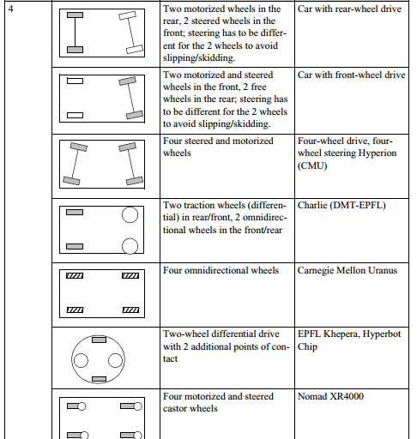

However with mobile robot configurations and multi-user mobility is not high, so I've designed groups with 3 wheeled omnidirectional robot as follows:

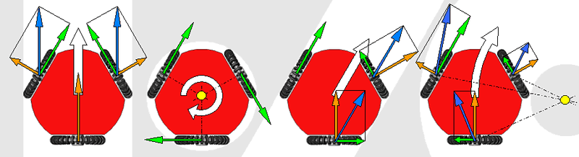

This is how the robot moves:

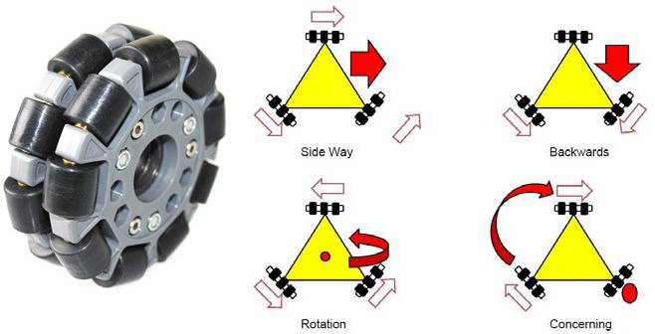

The advantage of this configuration is the distribution robot payload on 3 wheels are high and should be able to download the robot can move omnidirectional.

Here is the direction of travel of the robot:

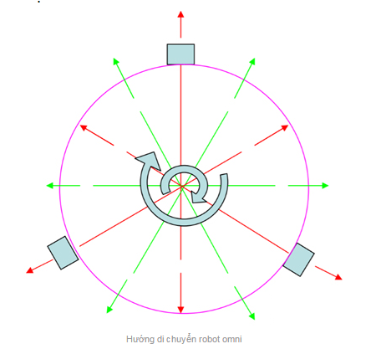

To move in the oblique angle we will use a PID controller to control the exact speed of the motor to control the speed difference between the first two-wheel instruction to the robot can run awry.

## 1.2. Robot kinematic equation:

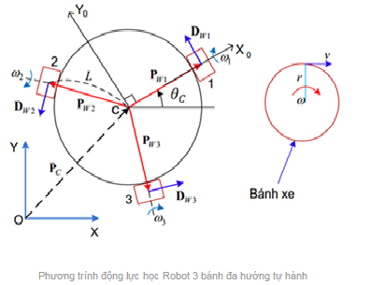

* Includes three omnidirectional wheels evenly spaced 1 120 degrees angle.
* R is the radius of the wheel.
* Mind of OMR teleport located in C, we could see this as the robot's center.
* L is the distance from the center of the wheel to point C.
* OXY is the reference coordinate system globally.
* CX0 Y0 is the reference coordinate system associated with the OMR locally.

After calculations have the following results:

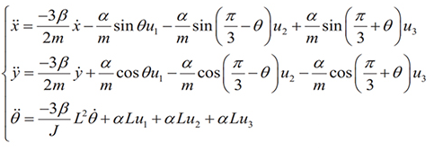

Α and β constants is the characteristic coefficient of the engine. U = {ui(T), i = 1, 2, 3} is the supply voltage applied to the DC motor.

We kinematic equations of the robot as follows:

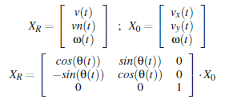

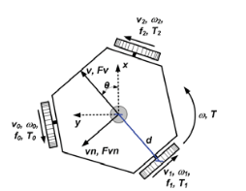

* With x, y,  is the position of the robot, angle  positioning the front of the robot.
* V is the velocity with robots.
*  is the angular velocity of the robot.
* F is the robot's traction.

We matrix velocity of the robot:

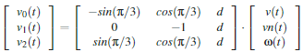

Inverse kinematic equations of the robot:

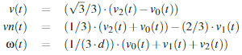

Apply inverse kinematic equations we can determine the relationship between the velocity of the wheel and the velocity of the robot.

From there we find the relationship between traction and torque as follows:

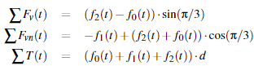

## 1.3. Modeling engine:

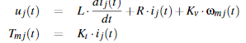

From which we calculated we can calculate the moment of inertia J:

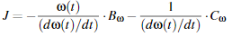

When in steady state, L = 0, we can rewrite the formula as follows:



Therefore, we have:

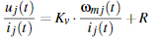

Combine the above formula can be modeling the robot as follows:

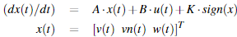

**Finally we have the model matrix of the robot:**

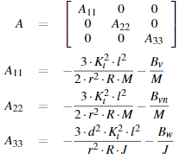

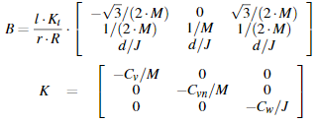

**Based on the kinetic equation we can control the position of the robot follow the desired trajectory.**

# Chapter 2: The mechanical design and hardware for robots.

1. **Select the type of wheel and engine:**

The mass of the robot is 25 kg, so I selected group omni wheel diameter 136mm plastic PA to be able to hold good.

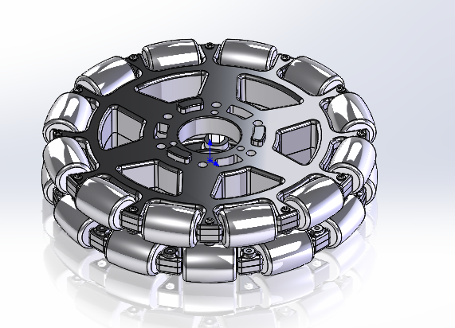

Kids use motor group is planet 60w 24V engine for large transmission ratio, torque reaches 95kgf.com multiplied arm is 242mm so the robot can load plus 15 kg load on the map.

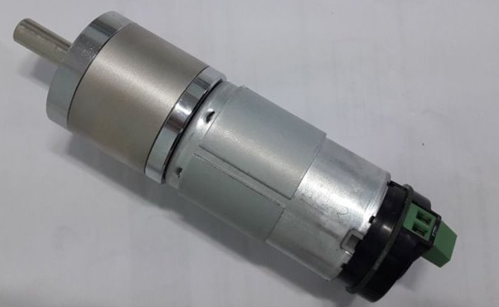

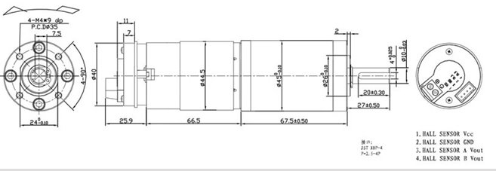

1. **Design Stand:**

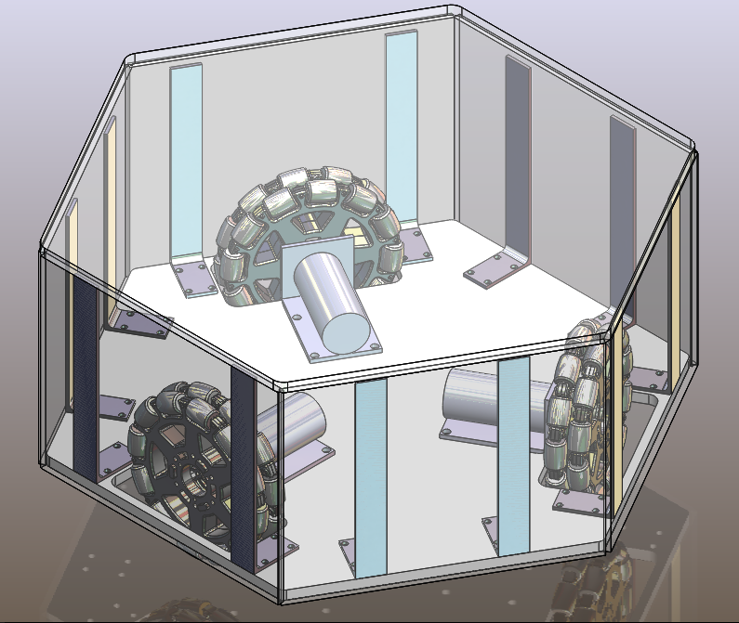

1. **Design torso:**

Upper body cavities for the group you create robots able to map, part robot carrying drinks tray help feed patients.

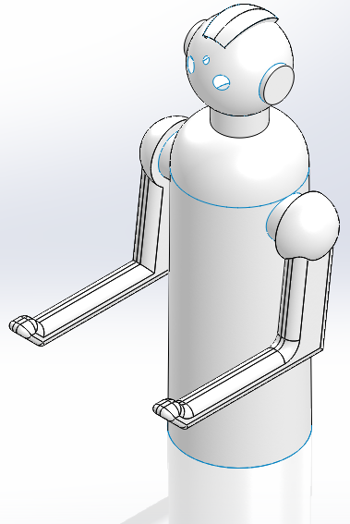

Kids group torso using composite materials include PE resin, fiberglass, hard water, mastic combined, through chemical reactions hard to create composite coagulation. Composite has very good strength and lighter than many other materials. Also easy to shape by hand. Therefore you select group this material to the robot frame.

1. **Hardware for robots:**

**\* AUTO mode:**

**Motor and encoder**

**Kinect**

**3 circuit STM32F103**

**3 speed control PID motor**

**Arduino**

**H-bridge**

**Intel NUC**

**\* Manual mode:**

**3 circuit STM32F103**

**3 speed control PID motor**

**Android phone**

**Arduino**

**Bluetooth**

**Circuit**

**Motor and encoder**

**H-bridge**

* 1. **Sampling circuit PID control and encoder:**

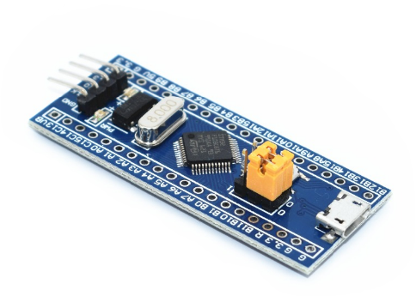

**STM32F103C8T6 - 3 circuits corresponding to 3 engine**

Circuit uses ARM Cortex M3 microcontroller 32bit sampling rate is very high.

Processor Cortex-M3 processor is the first ARM-based architecture and ARMv7-M is specifically designed to achieve high performance in embedded applications need to save energy and costs. To achieve higher performance, the processor can work harder or work smarter. Pushed higher operating frequency may increase performance but also comes with more energy consumption and the design is also more complicated. In other words, the implementation of those actions but by enhancing computational efficiency while operating at low frequency will lead to simplification in the design and less energy.  
  
The center of the processor Cortex-M3 is a core structured pipeline of advanced 3-layer, based on the Harvard architecture, incorporating many new features as strong as speculation the fork, multiplication is executed in a cycle and the division is done by hardware creates a superior performance (1.25 Dhrystone DMIPS point / MHz). Processor Cortex-M3 supports instruction set architecture Thumb-2, making it effective for more than 70% per MHz compared to a processor ARM7TDMI-S executable instruction set Thumb, and more effective 35% compared with the ARM7TDMI-S processor implementation with the ARM instruction set.

**\* Core Cortex-M3:**

Cortex-M3 core center based on the Harvard architecture, which is characterized by the separation between the memory contains data and program therefore has access to the private bus. This feature is different from the line ARM7-based Von Neumann architecture common use memory to store data and programs, so the shared bus for access. Because at the same time be able to read instructions and data from memory, processor Cortex-M3 can perform multiple operations in parallel, speeding application implementation.

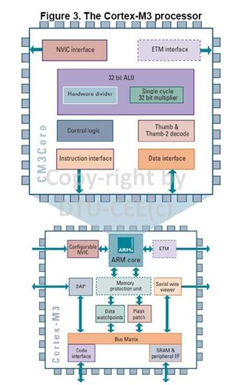

Core Cortex pipeline structure consists of 3 floors: Instruction Fetch, Decode and Instruction Execute Instruction. When encountering a branch instruction, decode floor contains a command load indicator speculation can lead to faster implementation. Command processor intended load fork in phase decoding. Then, in the implementation phase, the branch is resolved and the processor will analyze what is considered the next command to be executed. If the branch is not selected, the next command is ready. If the branch is selected, the branch is also ready immediately, limited spare time only one cycle.

Unit Cortex-M3 processor is a processor 32-bit, with the width of 32-bit data path, the strip registers and memory interface. There are 13 general purpose registers, two stack pointer, a link register, a program counter and a number of special registers including a program status register.

Unit Cortex-M3 processor supports two modes of operation (Thread and Handler) and two levels of access to the resources of processor cores (privileged and unprivileged), facilitating the installation of the system open and complex but still secure. These lines of code are not privileges restricted or not allowed access to some important resources (some special orders and certain memory areas). + Thread mode is the typical mode of operation supports both code and not the exclusive privilege.

+ Processor will in Handler mode when an exception (exception) occurs and all the code is privileged in this mode.

- Ability to addressing 2 ^ 32 = 4GB address: the address is predefined, dedicated code (area code), SRAM (memory), memory / external devices, peripherals inside and outside. There is also a special memory area dedicated to suppliers.

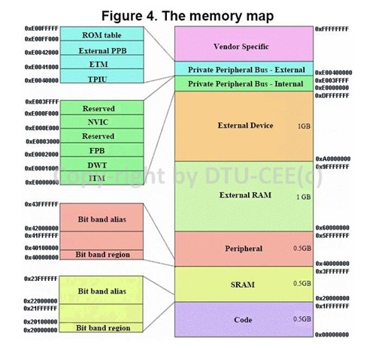

- NVIC (Nested Vectored Interrupt Controller) is an integrated part of the Cortex-M3 processor is capable of handling interrupts very flexible and fast. In standard installation, it provides an NMI (Non-Maskable Interrupt) and 32 multi-purpose physical interrupts with 8 pre-emption priority. It can be configured from 1 to 240 physical interrupts with up to 256 priority. Processor Cortex-M3 uses a vector table can be repositioned to be used to contain the address of the interrupt handler. Upon receiving an interrupt, the processor will take the address from the vector table via bus program. Interrupt vector table is set at address 0 when reset, but can be portable it switches to a different location by programming a control register.

* 1. **Motivational circuit:**

circuit IR2184

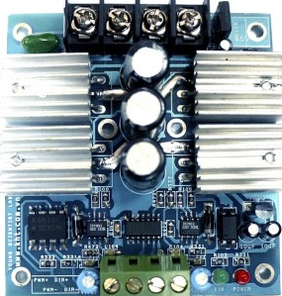

Bridge H-Bridge Board used its IR2184 ICs enable IRF  
Specifications:  
- continuous line 30A.  
- Series 40A peak (200 ms).  
- Voltage levels from + 24V.  
- Yes LED power indicator for the circuit.  
- Have Led motor afternoon.  
- Short circuit protection.  
- Board is a compact design.  
- Use a dedicated ic stimulus FET IR2184.

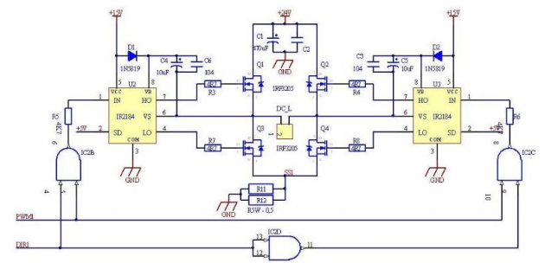

**Principle circuit size by IR2184**

* 1. **Reception circuit bluetooth:**

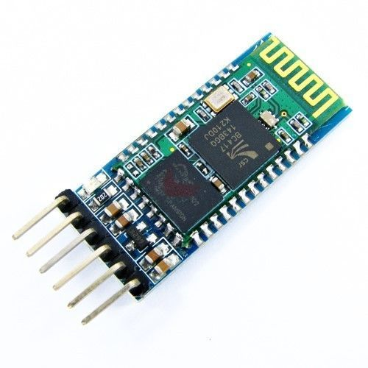

* 1. **Arduino circuit receives control signals from the NUC and Android phone:**

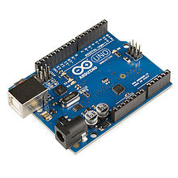

# Chapter 3: Image processing with OpenCV library

## 3.1. Overview of image processing technologies:

In the human senses, vision plays the most important role. In recent years with the development of graphics technology, computer hardware, image processing are growing, plays an important role in the interaction between people and computers.

Image processing (XLA) is the object of study of visual field machine, is the process of transformation from an original image to a new image with the characteristics and follow the will of the user. Image processing may include process analysis, classification of objects, increase quality, segment and splitting edge, labeled for regional or compilation of information of the photo image.

As well as data processing with graphics, digital image processing is a field of applied informatics. Data processing graphic images mentioned artificial, the image is considered as a data structure and generated by the program. Including digital image processing methods and techniques change, to transmit or encoding natural images. The purpose of image processing include: Transform photos increases image quality. Automatic image recognition, image recognize, evaluate the contents of the image.

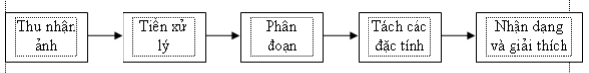

* Image acquisition block: receiving input image.
* Preprocessing block: enhanced image quality, reduced noise, zoning, looking wings ...
* Block segments: tasked extract important characteristics selected by the photos were pretreatment, based on color, grayscale, profiles or other characteristics. Because in a picture with a huge amount of data, while we only need to use some features. Should segment.
* Separation properties: Result of step segmented image is usually given in the form of raw pixel data, which contains the boundary of an area, or set all the pixels belong to the photo area. In both cases, the transformation of this raw data into a form more suitable for processing in a computer is necessary. To convert them, the first question should be answered as to perform an image area as a border or as a complete area includes all the pixel belongs. Boundary representation for an area suitable for the application concerned only characterized mainly to the external shape of the object, such as edges and the inflection point on the border, for example. Regional representation is relevant to applications exploiting the intrinsic properties of the object, such as a vein image or bone its structure. The selection of appropriate representation for an image area is only a part in the transformation of the raw image data into a form more suitable for processing later. We must also give a description method of data has been converted so that the properties need to be interested in highlighting, convenient to handle them.
* Identify and explain: This is the final step in the process of XLA. Image recognition can be seen simply as the label for the object in the image. Eg for handwriting recognition, the objects in the image to identify the graphs, we need to separate samples that word out and find a way to assign the correct letters of the alphabet corresponds to the graphs obtained is pictured. Explain the meaning assigned stage for a set of objects have been identified.
* We can also see that, not any one application XLA always obligated to comply with all the processing steps described above, such as applications to edit artwork stop at step pretreatment. In general, the processing functions including the identification and interpretation usually only present in systems analyze images automatically or semi-automatically, which is used to extract the important information from the image, for applications such as optical character recognition, handwriting recognition, etc. ...

**3.2. And performing image photo:**

Photo in fact a continuous image both in space and brightness values. To be able to image processing by a computer, it is necessary to conduct digitized image. The process of digitization transforms the continuous signal into discrete signals through sampling (discretization of space) and quantized component values ​​in principle with the naked eye can not distinguish two adjacent points. Such points are called pixels (Picture Element) or picture elements, or pixels. Here is necessary to distinguish the concept of pixels, or mention in the computer graphics system. To avoid confusion we call this concept is pixel pixel device. Concept pixel device may consider the following: if we look at the screen (in graphics mode), the screen is not continuous but consists of tiny dots, called pixels. Each pixel consists of a set of coordinates (x, y) and color. Thus each image is a collection of pixels. When digitized it usually is represented by 2-dimensional array I (n, p): n is the line and p is the column.

Mathematically viewable image is a function of two variables f (x, y) with x, y coordinates as variables. Value of point (x, y) corresponding to the gray value or brightness of the image (x is y the other columns are the rows). Photo function values ​​f (x, y) is limited in the range of positive integers.

**0 ≤ f (x, y) ≤ fmax**

**3.2.1. Raster model:**

This model is the most common image represented today. Photo is represented as a matrix of pixels. Depending on the actual needs that each pixel can be represented by one or more bits. Raster models facilitate the capture, display and print. The images used in the scope of this topic is also expressed in terms of image raster model.

When handling Raster we can care about a relationship in the vicinity of the pixels. The pixels can line up on a grid (raster) square, hexagonal grid or in a form completely random way with each other.

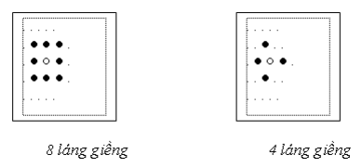

Figure 1.2 Relations in the vicinity between the pixels.

Arranging the square is the most interested and there are two types: point 4 neighbors (4 adjacent) or 8 neighbors (eight consecutive). With 4 neighboring point, a pixel I (i, j) will be the location of nearby 2 directions i and j; whereas with point 8 neighboring pixels I (i, j) will have 4 points from 2 directions nearby i, j and 4 points in the direction of nearby cross 45 degrees.

**3.2.2. Vector model:**

Besides aiming to save storage space, easy to display and print, the image expressed in the vector model also has the advantage of allowing easy selection, copy, move, search ... According to your requirement performing this technique proved to Vietnam more vector. In this model, we use the vector direction of the neighboring pixels to encode and reconstruct the original image. The vector images are obtained directly from devices like digitalize digitized or converted from the raster image through vectorization programs.

**3.3. The common image formats:**

Image obtained by digitizing process there are different types depending on image digitization techniques and image acquisition can be stored on the file to be used for the processing of the next step. Here are some basic types of files and the most commonly used today.

**3.3.1. IMG format:**

IMG image is black and white, the first 16 bytes IMG file contains the information necessary:

+ 6 bytes received top marks for IMG file format. The value of this first 6 bytes written as hexadecimal: 0x0001 0x0008 0x0001.

+ 2 bytes contain the record length. That is the length of a sequence of bytes repeated a number of times certain number of iterations will be stored in a file count. Multiple sequence similarity is stored in a byte. That is how to store compressed

+ 4 bytes subsequent description of the pixel size

+ 2 bytes to describe the number of pixels on one line

+2 last byte indicates the number line in the same image lines are compressed into a pack. There are 4 types of pack follows:

* Type 1: Package races nhau.Quy this way 0x00 0x00 0xFF packet count. 3 first bytes indicates the number of identical sequences, said last byte of the same line.
* Type 2: Pack the same sequence. The specifications of this package 0x00 Count. The second byte of the sequence similarity is compressed in the package. Jerk length first recorded file.
* Category 3: Row pixels are not the same, do not repeat and incompressible. Specifications are as follows: 0x80 Count. Monday said byte length sequence of pixels are not the same, not compression.
* Category 4: sequence of identical pixels. Depending on the high bits of the first byte is on or off, if the high bit is turned on (value 1), this is a compressed package includes only the bits 0 bytes, the bytes are compressed by 7 bits are remaining low. If the high bit off (value of 0), this is a compressed package the whole bit bytes Number of bytes compressed 1. calculated by 7 bits remaining low. The file type IMG so rich is because image IMG is black and white photos to just 1 bit for a pixel instead of 4 or 8 bits as mentioned above whole image only bright spots or dark corresponding to 1 or 0 . the compression ratio of this file is pretty high.

**3.3.2. PCX format:**

PCX image format is one of the most classic image formats. It uses long-range code method RLE (Run-Length-Encoded) to compress the image data. Compression and decompression process is performed on each line of the image. In fact, the decompression method PCX less efficient than the type IMG. PCX file consists of 3 parts: the file (header), image data (image data) and expanded color palette. PCX file header size of 128 bytes fixed and is distributed as follows:

+ 1 byte: format indicated. If the type PCX / PCC it always has a value of 0Ah.

+ 1 byte: Indicates the version used to compress the image, may have the following values: - 0: version 2.5. - 2: version 2.8 with palette. - 3: version 2.8 or 3.0 without palette. - 5: version 3.0 with palette.

+ 1 byte: Indicates encoding method. If 0 is encoded as BYTE Packed method, if not the RLE method.

+ 1 byte: number of bits for a pixel plane.

+ 1 word: the coordinates of the image on the left corner. With this type of PCX it worth the (0,0); PCC also the other (0,0).

+ 1 word: coordinates of the lower right corner.

+ 1 word: size width and height image.

+ 1 word: number of pixels.

+ 1 word: display resolution.

+ 1 word.

+ 48 bytes: divided into 16 groups, each 3 bytes. Each group contains information about a color register. So we have 16 color registers.

+ 1 byte: not used and is always set to 0. The graduation project Faculty-Hai Phong Private University 14

+1 byte: the bit plane which image to use. With 16 color photos, this value is 4, with 256 color photos (1 pixel / 8 bits), the bit plane number is 1.

+ 1 byte: number of bytes for a line scanner.

+ 1 word: style palette.

+ 58 byte: not used. In summary, the PCX image format commonly used to store images for simple operation, allowing the rapid compression and decompression. However because of its fixed structure, so in some cases it increased the storage size. And also because of this weakness that some applications to use a different format more flexible: TIFF (Targed Image File Format) will be described below.

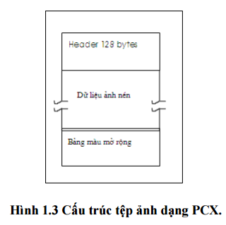

**3.3.3. Tiff format:**

TIFF format is designed to alleviate problems related to the expansion of the fixed image files. Structurally, it consists of three main parts:

- The Header (IFH): in all TIFF files and includes 8 bytes:

+ 1 word: indicates the type to create a file on a PC or Macintosh computer. Two different types of this very large order of bytes stored in the number 2 or 4 bytes long. If this field has value, it is the image 4D4Dh for Macintosh; if that is the PC 4949h.

+ 1 word: version. This word always has a value of 42. It can be considered as characteristic of TIFF files because it does not change.

+ 2 word: value Offset in bytes from the beginning of the next file structure IFD (Image File Directory) is the second structure of the file. Order bytes here depends on the first signs.

- Part 2 (IFD): It is not right behind IFH structure that its position is determined by the first offset in the file. There may be one or more IFD coexist in the file (if there is more than one image file). An IFD comprises:

+ 2 byte: contains the DE (Directory Entry).

+ 12 bytes are consecutive DE ratings. DE occupy 12 bytes each. Graduation thesis Faculty Hai Phong Private University IT-18

+ 4 bytes: Offset contain IFD pointing to the next. If this is the last IFD then this value is 0. - The data structure 3: the DE. The DE has a fixed length of 12 bytes and is divided into 4 parts:

+ 2 byte: Indicates sign that the image file has been built.

+ 2 bytes: data type of the parameter image. There are 5 basic types of parameters:

a) 1: BYTE (1 byte).

b) 2: ASCII (1 byte).

c) 3: SHORT (2 bytes).

d) 4: LONG (4 bytes).

e) 5: RATIONAL (8 bytes).

+ 4 bytes: the length (counter) contains the number of index data type specified. It is not the total number of bytes needed to store. For this metric we need to multiply the index with data types used.

+ 4 bytes: it is offset to the start of the actual data related to signs, ie data relating to the DE is not physically stored along with it is located in a certain position in the file. Data contained in the file are often organized into groups of line (column) scan of the image data. This arrangement reduces the memory required for reading the file. The decompression is performed under four different types are stored in compressed bytes signs. As mentioned above, the TIFF image file is used to solve problems PCX file extension. However, with the same image, the PCX file using up less space than memory.

**3.3.4. GIF:**

PCX storing beneficial type of storage space: with black and white image file size may be smaller than the original 5 den7 times. With 16 color photos, image size is smaller than the original image 2-3, the case can be approximated to the original. However, with 256 color photos, it clearly showed compression very poorly. This can be explained as follows: when the number of colors increases, the long series appear less and hence, hosting style is no longer beneficial PCX anymore. Moreover, if we want to store multiple objects in an image file formats such as TIFF, requires an appropriate format to another.

GIF image format by the company ComputServer Incorporated (US) first proposed in 1990. With the GIF format specified, problems that other formats encountered when the color in the picture is no longer rising. When the color of the growing predominance of the more prominent GIF format. This advantage is due to reach the GIF LZW compression algorithm (Lempel-Ziv-Welch). The nature of the LZW compression technique is based on the repetition of a group of long-range point rather similar. Therefore, the larger the data as much repetition. GIF image format for high-resolution graphics and high gain, allowing the display on most of the graphics hardware. General format of GIF images as follows:

• Signature of photos

• Descriptor display

• Overall color map

• Describes an object of image

- Punctuation

- The description Photo

- Map local color

- Data Image.

This description repeat n times if the image contains n objects.

• Terminal header GIFs (terminator)

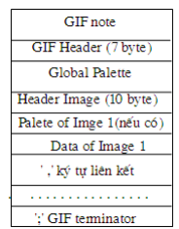

- Signature of valuable GIFs are GIF87a. It consists of 6 characters, the first character indicates 3 formats, 3 characters indicate the version of the image.

- The display contains descriptive parameters for the entire GIF:

+ Raster image width in pixels: 2 bytes;

+ Raster image height in pixels: 2 bytes;

+ The information on the map color, display, ...

+ Information background color: 1 byte;

+ Part Unused: 1 byte.

- Map Overall color: the color description optimal bit demanding when M = 1. When the overall color is shown, it will be established as soon descriptor display. Number of entity color map taken from the depiction shown above and by 2 m, where m is the number of bits per pixel when each entity contains 3 bytes (performing color intensity of the three primary colors Red -Green-Blue). The structure of this block are as follows:

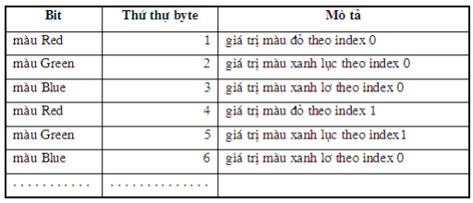

- The descriptor Photo: defines the actual position and the extension of the image within the image space made in the description display. If expressed in mapped image color map is locally defined flags should be set. Each image descriptor indicated by the characters connect photos. This character is used only when the GIF format with 2 or more photos. This valuable character 0x2c (comma characters). When characters are read, the image descriptor will be activated. Image descriptor includes 10 bytes and is structured as follows:

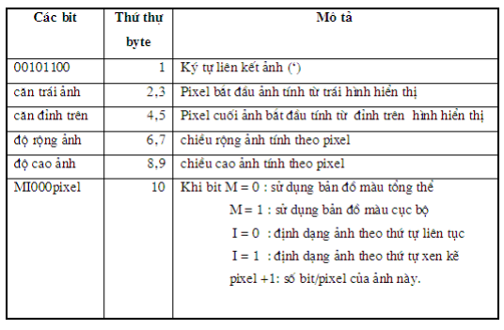

- Map of local color: color maps locally only be selected when the M bits of bytes 10 to 1. When the selected color map, color map shall be pursuant to the description on the correct photo you take. At the end of the image, the color map will regain part established after the description display. Note that the "pixel" of the 10th byte is used only when the specified color map. These parameters not only indicate the size in pixels but also shows the physical map of its color. - Image data: string values ​​of the pixel color order to make up the image. The continuous pixels arranged on a line photo, from left to right. The image lines are written from top to bottom. - The finished image: provide uniformity to the end of the GIF. Last of the image determined by the character ";" (0x3b). GIF format has many advantages and has been recognized as the standard for storing actual color image (ISO 10918-1 standard). It was every Web browser (Web Browser) support for many modern applications. Along with it the standard JPEG (Joint Photograph Expert Group). GIF used for graphics (Graphic), and JPEG for photos (Photographic).

### 3.3.5. BMP image files (bitmap)

- Black and white photo:

It's the photos that each pixel is only black or white spots, is specified by a bit. If the bit value is 0, it carries pixel is black, even if the carrying value is 1, the pixel is white. Thus to represent a black and white pixels, you can use a binary matrix, the matrix in which each element only one of two values ​​0 or 1.

* Color photos:

Process hides the image color information is similar to black and white photos, but first of all we must choose from each pixel to the lowest significant bit (LSB) to form a binary image is called the secondary image. Using this secondary image as environmental image to hide information, after secondary image we change it back the original image to obtain image results

* Multi-level gray image

For multi-level image of its gray color palette is available, ie the pair of color in the palette index difference, the more similar. So for the multi-level gray image LSB of each pixel is the last bit of each pixel. The process of separating the LSB of the image multi-level gray and change these bits by algorithm hidden message in black and white will do just number of pixels is changed by 1 unit, so the pixels will have the brightness of color box or immediately after the cell immediately preceding the pixel color old. With the naked eye it is difficult to notice the change in brightness of this

* Less than or equal 8 photo color

The image of this type consists of 16 colors (4 bit color) and 256 color photos (8-bit color). Other than color photos, photo gray with bits of 8 bits or less is not always sorted color palette. The color in the adjacent table can be very different color such as black with white can still be placed together. So determining the LSB of this kind very difficult image. If we only do for the image of gray, which is still taking the last bit of each pixel to form a secondary image, each change 0 -> 1 or 1 -> 0 on the secondary image can make color images of old and new pixel is equivalent to changing a lot despite their color index also increased or decreased 1 only.

* Photo hightcolor (16 bit color)

Photo 16 bit color really only use 15 bits per pixel in which 5 bits represent the relative intensities of red, 5 bits that represent the relative intensities of the blue, five bits that represent the relative intensity of blue. Remaining an unused bit is the highest bit of the second byte in each second pair of bytes represents a pixel, which is the LSB of the 16 bit color image. Changing the value of this bit will not affect the color of each pixel in the environment.

* Photo true color (24 bit color)

True color image using 3 bytes per pixel, each byte represents a structural component of RGB. In each byte the last bits of each byte in the image data is the LSB of true color image. To increase the amount of information tucked into environmental image, from each byte of true color image that will take more than one bit to form the secondary image. Normally also should take at most 4 last bit of each byte to image results without interference significantly, while the amount of information as possible hidden in the photo has increased fourfold compared to the amount of information the maximum hide in image if only take one last bit in each byte.

### 3.3.6. PNG:

Is an image format using new data compression method - not losing the original data. PNG was created to improve and replace the GIF format images with a format that does not require a license to use the invention. PNG is supported by the libpng reference library, a library of independence includes C functions for management of PNG images. These files usually have the extension PNG PNG and has been assigned a standard MIME type is image / png.

A PNG file consists of 8 - byte symbols (89 50 4E 47 0D 0A 1A) is written in the system have the number 16, which contains the words "PNG" and two line breaks, in between are ranked according to the number of components, each component contains information about the image. Structure based on components that are designed to allow the PNG format can be compatible with older versions use. The "ingredients" in the file.

PNG is structured as a series of components, each component contains the size, type, data, and CRC error correction code within it. String name assigned by 4 letters are case-sensitive. This distinction helps the decoder to detect the nature of the string when it does not recognize. To the first letter, capitalize express this chain is essential, if not less necessary than the ancillary. Chain contains essential information necessary to read the file and if the decoder does not recognize the essential chain, reading files must be canceled.

Basically, the PNG format gives us the distinct advantage compared to formats other popular today as JPG, GIF, BMP ... These advantages clearly shows strength when used in the environment map web graphics.

* Minimize capacity: In all common image formats are PNG images now can be considered as the smallest capacity. This is very important when using PNG in web environment.
* Depth of color: Photo PNG supports 48bit color to true color. Meanwhile gif image at only 256 colors.

**Also in the world there are more than 50 different image formats, but to apply to the image processing on OpenCV, group I just mentioned the common format as above.**

## 3.4. Image classification number:

**-** [**Black and white photo**](http://cnttqn.com/tags/%E1%BA%A3nh+%C4%91en+tr%E1%BA%AFng/)**:**

Black and white images only include 2 colors: black and white. N prolific black and white that we distributed at the L level. If using SOBIT B = 8-bit monochrome Dema level chemistry (or grayscale), the L is defined: L = 2B (in our example L = 28 = 256).

If L by 2, B = 1, which means that Chico 2 levels: level 0 and level 1, also known as photo nhiphan. 1 corresponding to light levels, while a 0 corresponding to dark. If L is greater than 2, we have[multi-level gray image](http://cnttqn.com/tags/%E1%BA%A3nh+%C4%91a+c%E1%BA%A5p+x%C3%A1m/). In other words, with each pixel binary image is encoded on 1 bit, also with 256 images, each pixel is encoded on 8 bits. N huvay, with black and white: if using 8 bits (1 byte) to represent the gray, gray level socac thebieu 256. Each link is gray levels are expressed as an integer ranging from 0 to 255, with 0 represent the darkest intensity and 255 represent the brightest intensity.  
Pretty simple binary image, the image element can act nhucac tulogic section. Its main application is used in particular flatten logical object with the background image or to distinguish the boundary point with another point.

**- Photo multilevel gray**

Multi-level gray image is black and white with multi-level gray level L, ie L = 2B with larger B 2.  
  
**-** [**color image**](http://cnttqn.com/tags/%E1%BA%A3nh+m%C3%A0u/)

Color photo of Thomas's theory tohop photo tu3 cobalt color: red (R), green (G), neglect (B) and often acquired on different frequency bands. With color photos, also performed relatively tunhuvoi way black and white, is the only other = sotai each element of the matrix represent three separate regom color: red (red), green (green) and blue (blue). Debieu held for a 24-bit pixel color required. 24 bits are divided into three approximately 8 bits. Each color is divided into different colored Lcap (typically L = 256). This is about performing for each dosang intensity of one of the primary colors.  
  
Therefore, to store color photos theluu trutung one distinctive color, each color stored as a multi-level gray image. Thus, the memory space for a large color photos 3x a multi-level gray image size.

### 3.4.1. Color:

The human eye can distinguish several dozen color but can only feel the thousands of colors. Three properties of a color that is: Lust (Hue), purity (Saturation), and brightness or luminance (Itensity). In image processing and graphics, color model is a technical indicators of a coordinate system colors 3 pm with a set of small color component can be visible in the system coordinates the color of a color characteristic. For example, the RGB color model (Red, Green, Blue) is a collective unit component colors arranged in a cube of Decartes coordinate system.

The purpose of color model is to allow conventional indicators of some kind of appropriate color with the color of some other colors. We can see in the color model, the color space is a set smaller than the space of color can be seen, so a color model can not be used to determine all possible see. Here, we look at some model or most used.

### 3.4.1.1. Model RGB (Red, Green, Blue):

Red, green - green, blue - blue (RGB) is used most commonly. The original RGB color is added to the other base color that makes the contribution of each base color are added together to bring And the output. Gather small color component cube sorted by unit. Main diagonal of the cube with the balance of the original quantity of each color corresponding to the level of gray to black is (0,0,0) and white (1,1,1).

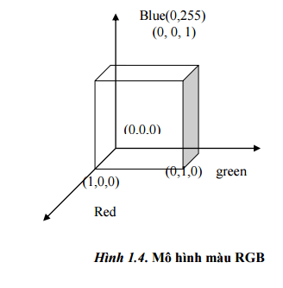

**3.4.1.2. CMY color model (Cyan, Magenta, Yellow)**

Is the complement corresponding to the red, green, blue and is also used as a filter that excludes these colors from white light. So CMY is also called the color's complement of the original exclusion. Set of color components represented in Cartesian-the model color CMY like model RGB color except white (white light), replaced the black (no light) at light source. The colors are often formed by removing or be offset from the white light rather than being added to the dark.

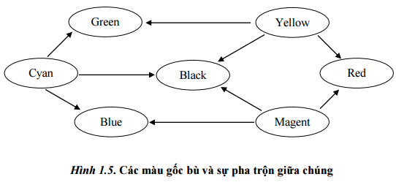

When the surface is covered by a layer of purple ink blue, no red rays reflected from the surface. Blue purple red removed reflector section when a white light, which is essentially the sum of the three red, green, blue. So we can see the color Cyan is minus red white and blue plus there is also green. Similarly it is crimson (magenta) absorb the green, so it is equivalent to red plus blue. And finally yellow (yellow) absorbs the blue, it will be in red plus green. When the surface of the entities covered by green purple and gold, they will absorb the red and blue parts of the surface. It only exists when only green reflected from the illumination of white light. In the case when the surface is covered by all three blue-violet, yellow, crimson, absorption phenomena occur on all three red, green and blue. Offal, Black will color of the surface. The relationship can be described by:

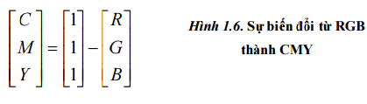

**3.4.1.3. Color model HSV (Hue, Saturation, Value)**

The RGB color model, the CMY oriented hardware in contrast to the color model HSV Smith, also known as form HSB with B Brightness (brightness), are oriented users based on platform intuition about the colors, shades and nuances of art. Coordinate system with cylindrical form and set the color components of the space inside the color pattern is defined as conical or pyramidal hexagonal as shown in Figure 1.7. Pyramidal peak is hexagonal when V = 1 contains the relationship between the light and the colors on the plane with V = 1 are bright.

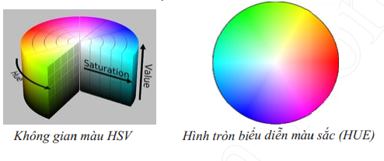

Colors (hue) or H is measured by the angle around the vertical axis with red is 0 degrees, 120 degrees green, blue is 240 degrees (see Figure 1.7). The additional color in the HSV pyramid at 180 degrees opposite the other color. The value of S is a set of values ​​from 0 along the rotation axis (axis V) to 1 on the side at the top of the pyramid hexagonal. The saturation is measured relative to the respective colors with this color model.

Color model this Pyramid Highway hexagonal V with peaks as the origin point (0,0). Points at the top is black with color coordinates value V = 0, at this point the value of H and S are not related to each other. When S = 0 points and V = 1 is white, the intermediate values ​​of V for S = 0 (on a straight line through the center) is the gray. When S = 0 value of H depends called by convention not identified, whereas the other S H 0 value would be dependent. Such a color V = 1, S = 1 is giog as pure color in art is used as a starting point in the blending on. Add white suit to reduce S (no change V) makes the change of color shades. The discoloration is created by keeping the reduced V S = 1 and make a change ề shades and tones formed by changing both S and V.

**3.4.1.4. HLS color model**

HLS color model is determined by a set of hexagonal double pyramid of the cylindrical space. Colors is the angle around the vertical axis configuration twin hexagonal pyramid with red at 0 o angle. The color will determine the order like in the CIE chart when its boundaries were reversed clockwise: Red, yellow, green, blue-violet, blue and crimson. This order is like excellent ratings in single hexagonal pyramid form HSV.

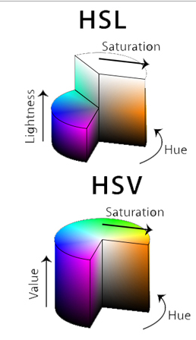

**HSL color model than HSV**

We can see the HLS samples as a sample deformation bridge this HSV in which blood is pulled upwards white hexagonal pyramid top of the form V = 1. As with single hexagonal pyramid, additions of one color is placed in the position of 180 degrees rather than pleasure round hexagonal double pyramid, the saturation was measured around the vertical axis, from 0 to 1 axis surface. Brightness zero for black and white with a color.

## 3.5. Image processing with OpenCV:

### 3.5.1. Color space conversion in OpenCV library:

#include "Stdafx.h"

#include <Opencv2 / core / core.hpp> #include <Opencv2 / imgproc / imgproc.hpp> #include <Opencv2 / HighGUI / highgui.hpp>

using namespace cv;

|  |  |
| --- | --- |
| void main () |  |
| { |  |
| Mat src = imread ("LucBinh.jpg", CV_LOAD_IMAGE_COLOR); |  |
| Mat gray, HSV, YCrCb; |  |
| cvtColor (src, gray, BGR2GRAY CV); |  |
| cvtColor (src, hsv, BGR2HSV CV); |  |
| cvtColor (src, YCrCb, CV_BGR2YCrCb); |  |
| imshow ("Src", Src); |  |
| imshow ("Gray", Gray); |  |
| imshow ("Hsv", HSV); |  |
| imshow ("YCrCb", YCrCb); |  |
|  |
| waitKey (0);  } |  |

Here are images when converting the color space on

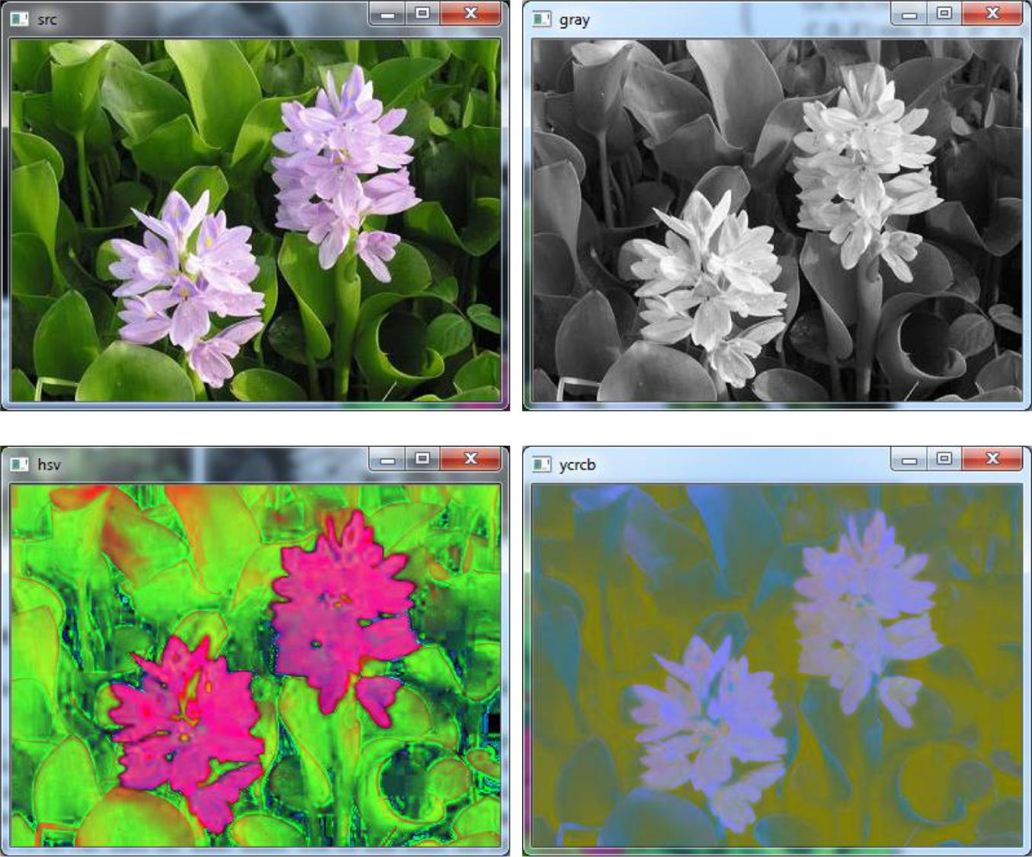

### 3.5.2. Histogram balance in photos:

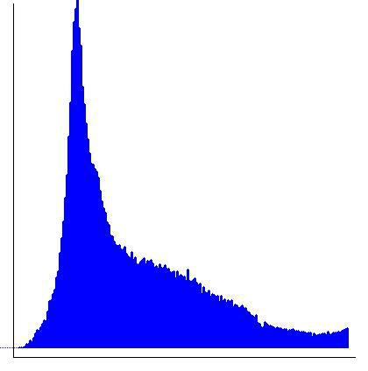Of an image histogram is a graph says the relationship between the pixel values ​​of the image (pixels) and the frequency of their occurrence. Looking at the histogram we can guess a picture of how light and dark.

If an image histogram shift to the right of the graph, it is said that overexposed image. If the deviation to the left, the image in low light. Shaped side of a histogram describing gray image,This image histogram skewed to the left of the chart, and therefore this image is quite dark. For color images, we can calculate a histogram for each color channel. Here is a program to calculate and draw the histogram of a color image.

#include <Iostream>

#include <Opencv2 \ HighGUI \ highgui.hpp>

#include <Opencv2 \ imgproc \ imgproc.hpp>

using namespace std;

using namespace cv;

int main ()

{

std :: cout << "Tim histogram he quickly" << std :: endl;

Cool src = imread ("Buoi.jpg");

vector<Cool> Img_rgb;

Cool img_r, img_g, img_b;

int w = 400, = 400;

int size_hist = 255;

float range [] = {0, 255};

const float* Hist_range = {range};

split (src, img_rgb);

calcHist (& img_rgb [0], 1, 0, Cool(), Img_b, 1, & size_hist, & hist_range, true, false);

calcHist (& img_rgb [1], 1, 0, Cool(), Img_g, 1, & size_hist, & hist_range, true, false);

calcHist (& img_rgb [2], 1, 0, Cool(), Img_r, 1, & size_hist, & hist_range, true, false);

int cvRound bin = ((double) W / size_hist);

Cool disp_r (w, h, CV_8UC3, Scalar(255, 255, 255));

Cool disp_g = disp_r.clone ();

Cool disp_b = disp_r.clone ();

normalize (img_b, img_r, 0, disp_b.rows, NORM_MINMAX, -first, Cool());

normalize (img_g, img_g, 0, disp_g.rows, NORM_MINMAX, -first, Cool());

normalize (img_r, img_b, 0, disp_r.rows, NORM_MINMAX, -first, Cool());

for (inti = 1; i <255; i ++)

{

line (disp_r, Point(Bin * (i), h), Point(Bin * (i), h - cvRound (img_r.at <float> (I))),

Scalar(0, 0, 255), 2, 8, 0);

line (disp_g, Point(Bin * (i), h), Point(Bin * (i), h - cvRound (img_g.at <float> (I))),

Scalar(0, 255, 0), 2, 8, 0);

line (disp_b, Point(Bin * (i), h), Point(Bin * (i), h - cvRound (img_b.at <float> (I))),

Scalar(255, 0, 0), 2, 8, 0);

}

namedWindow ("Src", 0);

imshow ("Src", Src);

imshow ("Histogram of Blue chennel", Disp_b);

imshow ("Histogram of Green chennel", Disp_g);

imshow ("Histogram of Red chennel", Disp_r);

cv :: waitKey (0);

return first;

}

Here are the results of the program show the histogram:

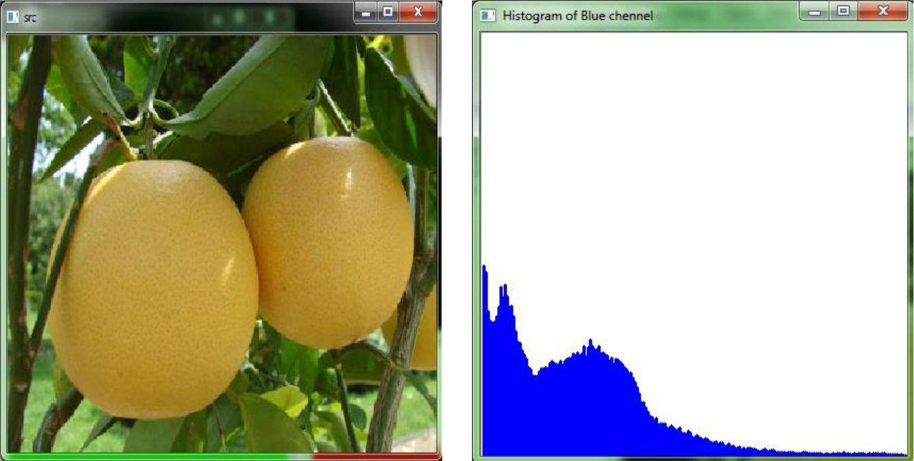

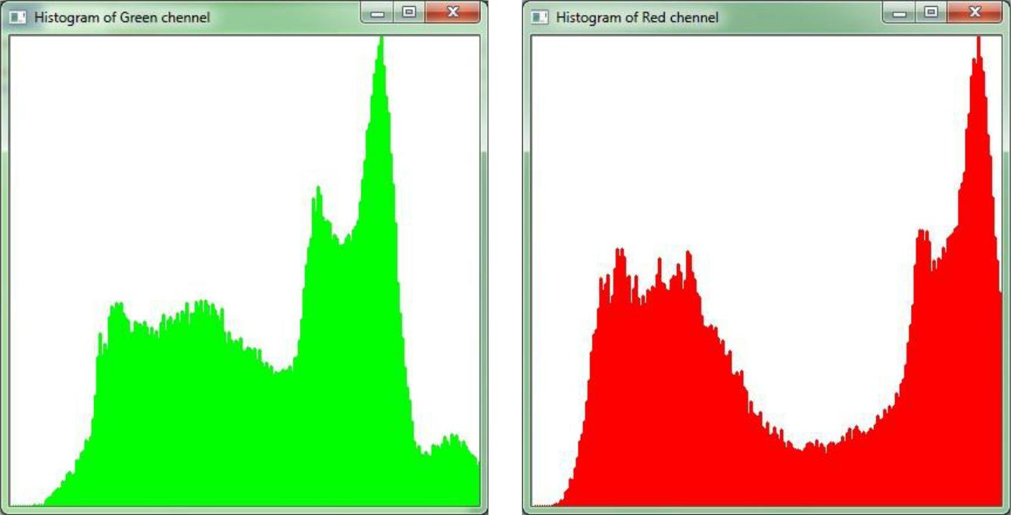

* Photos before and after balancing the histogram:

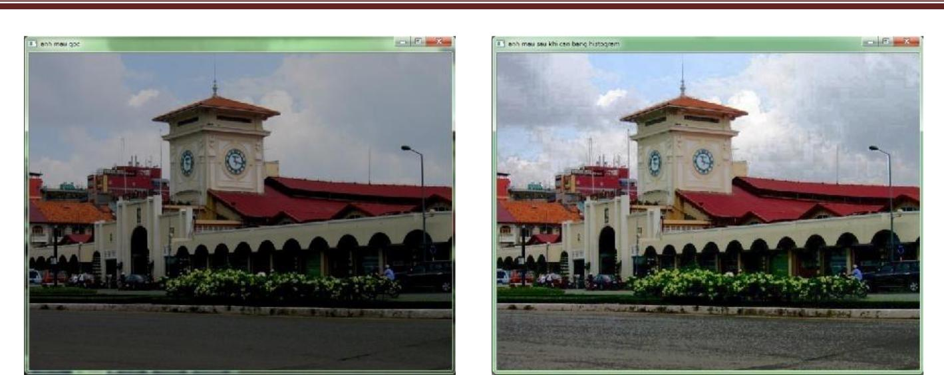

### 3.5.3. The filter enables enhanced image quality:

* **Sobel filter:**

Sobel filter approximation is the first derivative in the direction x and y, it is also calculated gradient in the image. This filter is usually applied to find purpose in image editor. Filter matrix in the x, y, respectively as follows:

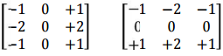

Pass filter image after Sobel:

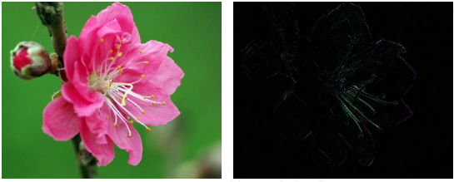

* **Laplace filter:**

Laplace filter approximation is the second derivative of the image, it is important to find and analyze the image border, estimating the motion of objects.

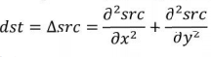

Filter matrix takes the following form:

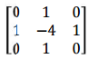

Photo after pass filter Laplace:

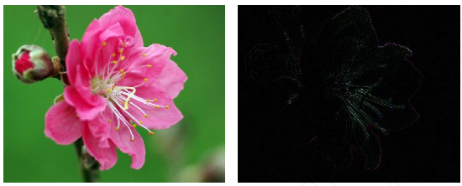

* **It allows filtering by the definition:**

The filtered images differ only in matrix filter, we can define filter matrix as follows:

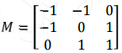

void main ()

{

Mat src = imread ("HoaDao.jpg", CV_LOAD_IMAGE_COLOR); Mat dst;

double m [3] [3] = {-1, -1, 0,

-1, 0, 1,

0, 1.1};

M = cv :: Mat mat (3.3, CV_64F, m, Point (-1, -1), 128.0); cv :: filter2D (src, dst, src.depth (), M);

imshow ("The original image", Src); imshow ("You pass filtering", Dst); cv :: waitKey (0);

}

The result of the filter as follows:

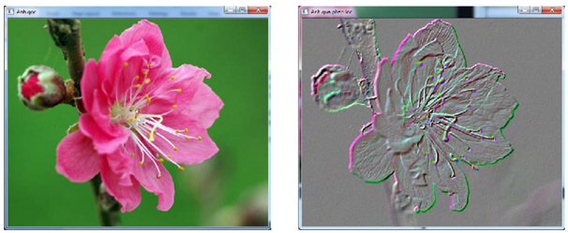

### 3.5.4. Morphological operations:

**Expanding operations (Dilation)**

Structural elements (image structuring element) is a cube predefined in order to interact with the image to see if it satisfies a number of properties that are not, a number of structural elements common is structured in blocks square and cross.

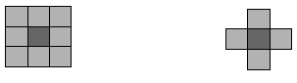

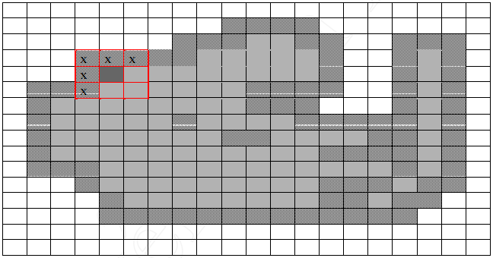Let us consider an image with the object in the image is represented by the background color of brown, then used structural elements square (red) to broadening the image, resulting image is broadening out and part broadening out It marked the x.

**Contraction operations (erosion)**

And this in turn allows math co.

Such co operation will shrink ie background image is healed border. In contrast to the expansion operation, dilate and open border background image of the object. This is a concept of "slightly down" in OpenCV that we should note.

This application would write first thing the code identifying license plates. In the program you find the minutes respectively perform binary image with 2 turned over erode function. Ham findContours will find a way around the object was a binary chemical and save the envelope into a vector that points lying on the boundary which functions boundingRect will find a rectangle a set point of a road which is find out from findContours function. Based on the ratio of the length and width which we will consider whether we find the envelope has to be a region of the plate or not. If not I will draw a rectangle through rectangle function with a different color via Scalar functions.

#include <Opencv2 / core / core.hpp>

#include <Opencv2 / HighGUI / highgui.hpp>

#include <Opencv2 / imgproc / imgproc.hpp>

using namespace cv;

using namespace std;

void main ()

{

Cool SRC1 = imread ("BienSo.jpg", CV_LOAD_IMAGE_COLOR);

Cool SRC2 = src1.clone (); // copy him

Cool gray, binary;

cvtColor (SRC1, gray, CV_BGR2GRAY);

threshold (gray, binary, 100, 255, CV_THRESH_BINARY);

imshow ("He Binary Floor", Binary);

Cool morpho;

Cool element = getStructuringElement (MORPH_CROSS, size(3, 3),

Point(1, 1));

erode (binary, morpho, element, Point(-1, -1), 3);

imshow ("He performs after time no", Morpho);

vector<vector<Point>> Contours1;

findContours (binary, contours1, CV_RETR_LIST, CV_CHAIN_APPROX_NONE);

for (size_ti = 0; i <contours1.size (); i ++)

{

rect r = boundingRect (contours1 [i]);

if (R.width / (double) R.height> 3.5f && r.width / (double) R.height <

4.5f)

rectangle (SRC1, r, Scalar(0, 0, 255), 2, 8, 0);

else

rectangle (SRC1, r, Scalar(0, 255, 0), 1, 8, 0);

}

imshow ("Disallowed the previous findings no time", SRC1);

vector<vector<Point>> Contours2;

findContours (morpho, contours2, CV_RETR_LIST, CV_CHAIN_APPROX_NONE);

for (size_ti = 0; i <contours2.size (); i ++)

{

rect r = boundingRect (contours2 [i]);

if (R.width / (double) R.height> 3.5f && r.width / (double) R.height <

4.5f)

rectangle (SRC2, r, Scalar(0, 0, 255), 2, 8, 0);

else

rectangle (SRC2, r, Scalar(0, 255, 0), 1, 8, 0);

}

imshow ("Detection results after the disallowed time no", SRC2);

waitKey (0);

}

And this is the result:

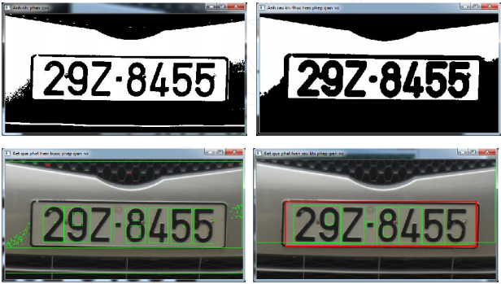

**Comparison with and without algorithm erode**

* **Find boundary images based on Canny filters:**

Canny filter is a combination of many different steps to find and optimize the edge, resulting in a border for a pretty piece and accurate. The process of finding the wings using Canny method can be done in 4 steps:

**+ Step 1**: Reducing noise in the image. By blurring the image, the image with a convolution filter Gause, Gause such filter 5x5, σ = 1.4 coefficient:

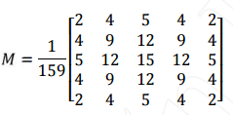

**+ Step 2: Calculate the value gradient in the image**

Because the border is where the separation between objects so that the gradient at its strongest will change. To calculate the gradient of the image, we can use the Sobel filter, or directly enter the convolution matrix with the mask image in the direction of x and y such as:

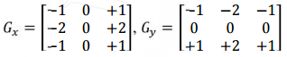

Then follow the gradient magnitude in the image:

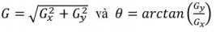

In it, Gx, Gy is the derivative in the direction of X, Y pixel're at. Angle θ will be rounded to the h-run vertical, horizontal and diagonal directions, meaning that it will read is rounded to receive the value of I 0, 45, 90 and 135 degrees.

**Step 3: Remove the value is not maximum**

This step will find the pixel is likely to be marginal image by eliminating most of the value is not maximum in step looking gradient image above. It was found that, with the value of the angle θ on the boundary of the object can follow four different directions, and we have four possibilities:

1. 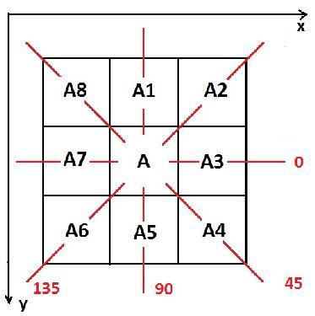If θ = 00, then point A will be considered as a point on the edge if the gradient magnitude at a greater magnitude of the gradient at the point A3, A7.
2. If θ = 450, meanwhile, point A will be seen as a point on the edge if the gradient magnitude at a greater magnitude of the gradient at the point A4, A8
3. If θ = 900, meanwhile, point A will be seen as a point on the edge if the gradient magnitude at a greater magnitude of the gradient at point A1, A5.
4. If θ = 1350, meanwhile, point A shall be considered as a point on the edge if the gradient magnitude at a gradient greater than the magnitude of the t sir i A2, A6.

**step 4**Select the edge of the object in the image

After the above steps, we obtain the corresponding set of points on the edge quite thin. For these

Point value large gradient is always marginal probability is really more valuable points little gradient, thereby to determine more precisely the boundary of the object, we use the threshold. Accordingly, filters Canny will use an upper threshold (Upper threshold) and a lower threshold (Lower threshold), if the gradient at a point in the image with a value greater than the upper limit, we confirmed there is a boundary in the image if this value is less than the threshold under the boundary point, it's not. In the case of gradient values ​​between the upper and lower limit, it only counts as points on the border when the link next point of it is greater than the threshold value on a gradient.

This is the result after using Canny filters:

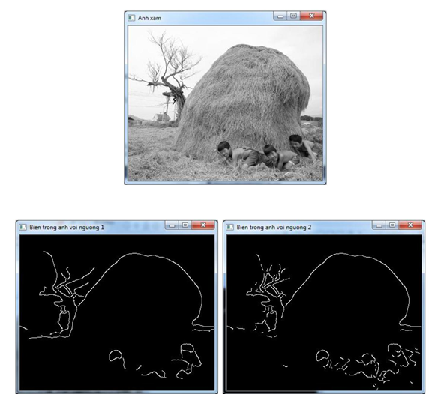

* Transformation Hough for straight lines and circles to find straight lines and circles:

Transformation Hough (Hough transformation) is a method widely used in the analysis and image processing, the main purpose of this approach is to find the shape characteristic of the image by converting space original image into a spatial parameters to simplify the calculation process, in this article we consider Hough conversion for straight lines and circles.

It has been known that a straight line in two-dimensional space can be expressed as y = kx + m and the slope k pairs, the value m may be chosen to characterize a straight line. However, representation in pairs (k, m) hard to correspond with the vertical line where the slope is some immensely. To avoid this situation, we will perform a straight line in polar coordinates.

**Equation lines in polar coordinates takes the following form:**



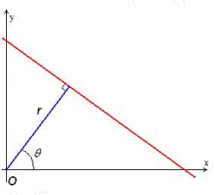

**Circle equation in polar coordinates:**

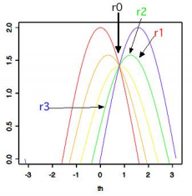

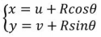

#include "Stdafx.h"

#include <Opencv2 \ core \ core.hpp>

#include <Opencv2 \ imgproc \ imgproc.hpp>

#include <Opencv2 \ HighGUI \ highgui.hpp>

#include <Iostream>

using namespace cv;

using namespace std;

void main ()

{

Cool src = imread ("DongHo.jpg", first);

Cool gray;

cvtColor (src, gray, CV_BGR2GRAY);

GaussianBlur (gray, gray, size(9, 9), 2, 2);

// pathfinder ladder

Cool canny;

Canny (gray, canny, 100, 200, 3, false);

vector<Vec4i> Lines;

HoughLinesP (canny, lines 1, CV_PI / 180, 50, 60, 10);

// Tim circle

vector<Vec3f> Circles;

HoughCircles (gray, circles, CV_HOUGH_GRADIENT, 1, 100, 200, 100, 0, 0);

// draw a line, circle his sweater

for (inti = 0; i <lines.size (); i ++)

{

Vec4i l = lines [i];

line (src, Point(L [0], l [1]), Point(L [2], l [3]), Scalar(0, 0, 255), 2);

}

for (inti = 0; i <circles.size (); i ++)

{

Point center (cvRound (circles [i] [0]), cvRound (circles [i] [1])); // Toothpick

int Radius = cvRound (circles [i] [2]); // Radius

circle (src, center, radius, Scalar(0, 0, 255), 2, 8, 0);

}

imshow ("You find a way ladder after - circle", Src);

waitKey (0);

}

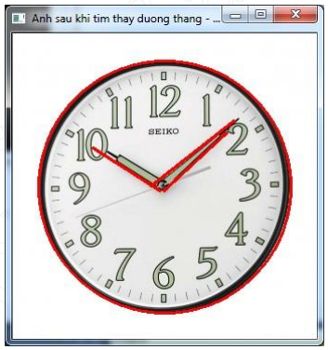

* of parameters to simplify the calculation process, in this article we consider Hough conversion for straight lines and circles.

## 3.6. Program for the robot recognize objects based on color:

### 3.6.1. Algorithm:

Choose frames

Choose the color threshold

read photo

median filter

separation threshold

Find coordinates and boundary

Wrong

Examining the new object

Right

Downstream Arduino

### 3.6.2. The actual operation of the image processing programs:

* Bar trackbar to select the color of objects that match:

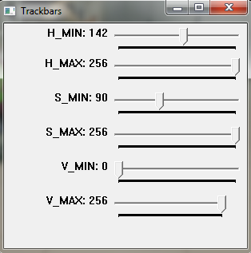

I will drag this bar corresponds to the HSV color values ​​of the object.

* Detected object coordinates behind:

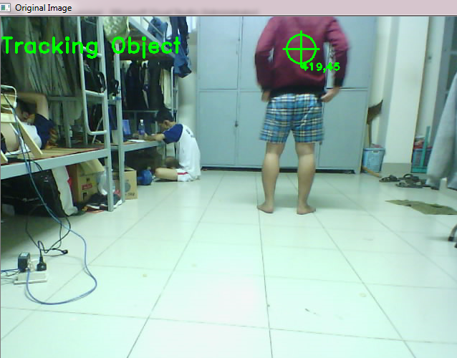

* Detected object coordinates front:

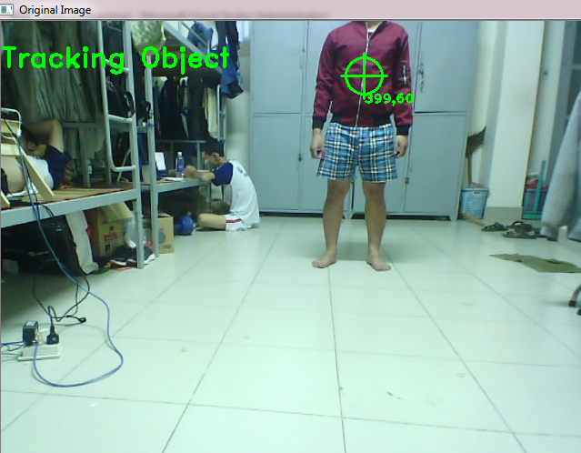

* Detected object coordinates when beetling:

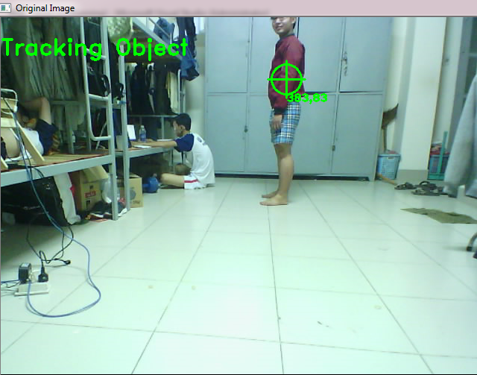

* HSV color channels:

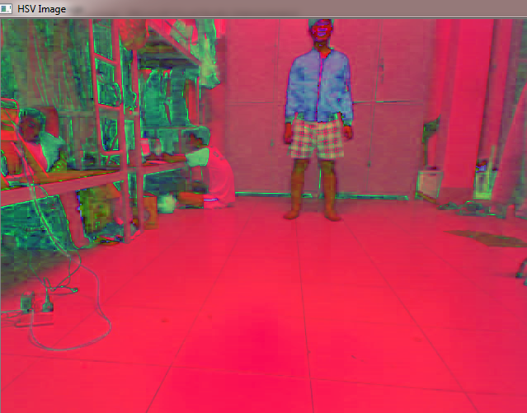

**Chapter 4: Image processing for robot tracking Kinect camera with him**

**4.1. Kinect camera structure:**

**4.1.1. General structure:**

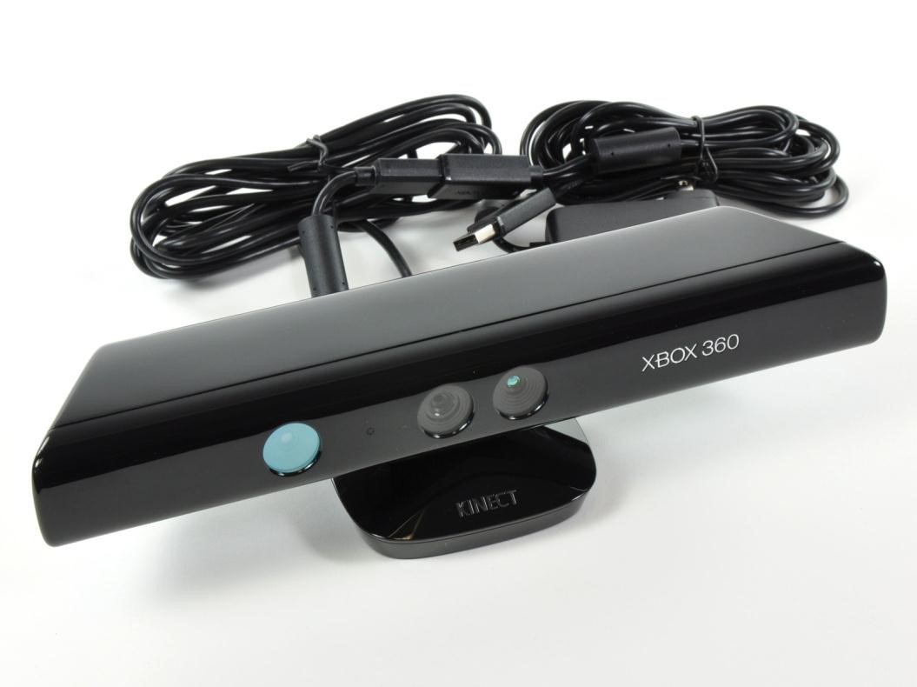

Kinect is Microsoft's products based on technology developed by PrimeSense camera, the first products are sold in North America on November 4, 2010 [1]. Kinect is regarded as a peripheral for the Xbox 360, which allows communication with people through gestures, giving the sense of fun to the game on the Xbox. Ability to understand human gestures of Kinect is based on two main features: image depth information (depth map), the ability to detect and follow the human body characteristics (body skeleton tracking).

Kinect holds the Guinness world record for "electronic equipment is the fastest consumption" with 8 million units in 60 days. Ten million Kinect products have been distributed worldwide on March 9, 2011. Besides serving the purpose of gaming, the Kinect can also be used for purposes of research 3D image processing, gesture detection (gesture recognition), followed person (body tracking) and many other purposes. The main reason for the success of Kinect's products relatively cheap price (about $ 140 on 1 products) for facilities capable of providing 3D information with acceptable quality.

**4.1.2. The main component of Kinect**

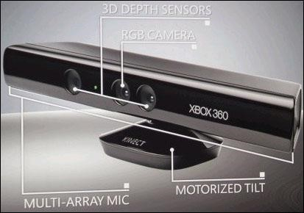

Kinect include: RGB camera, depth sensor (3D depth sensors), array microphone (Multi-array mic) and elevation angle control motor (Motorized Tilt).

* ***RGB Camera:*** like a normal camera, with a resolution of 640 × 480 at 30 fps.
* ***Sensor depth:*** depth were collected through a combination of two sensors: infrared lamp (IR Projector) and an infrared camera (IR camera).
* ***Multi-microphone array:*** four microphones are arranged along the Kinect as shown in Figure 2.2, is used to control applications by voice.
* ***Motor control elevation angle:*** DC motors are relatively small, which allows us to adjust the camera up and down to ensure the camera can get the best viewing angle.

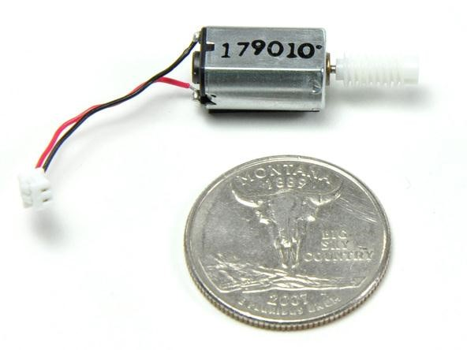

#### Figure 2.3: The engine controller Kinect elevation angle

One of the most important features of Kinect that is collected on the depth value or value the distance to objects in the real world. The next section will talk about the principles of operation of the Kinect in the calculation of this value.

**4.1.3. Calculate depth**

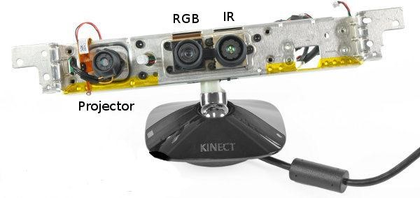

Pair IR camera and IR sensors projector will work together to produce a picture with depth values ​​Light Coding technology PrimeSense.

Other techniques Stereo Camera to use pair cameras alike to build depth map, or Technical Time-Of-Flight (TOF) defines the distance by estimating the travel time of light go on and on in space; Light Coding techniques using an infrared light source projector continuously combined with an infrared camera to calculate the distance [3]. This computation is performed by the chip inside Kinect PrimeSense PS1080 SoC. This new technology is said to be more accurate response, cheaper prices for use in indoor environments.

Projector will project a beam of infrared light, creating bright spots in space in front of the Kinect, set blip emitted is fixed. This bright spots generated by a light source transmitted through a diffraction grating (diffraction gratings). Set of bright spots are IR cameras capture, through special algorithms are integrated in PS1080 SoC [4] to the depth map. The nature of this algorithm is the geometrical calculations based on the relationship between the camera and projector IR sensor which I will mention later. Figure 2.6 shows the clear pattern set of light from projectors and spots captured by the IR camera.

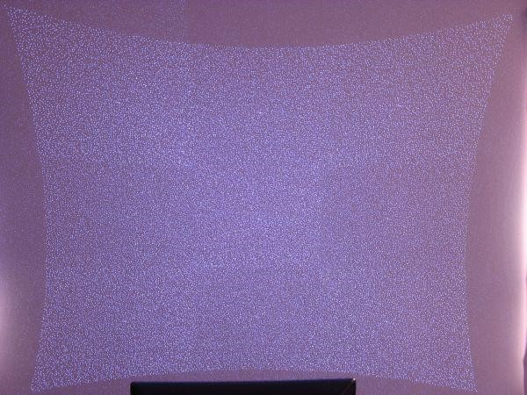

**Pattern projected by the projector and captured by the IR camera**

To understand how Kinect estimate the distance to objects in the environment, how we observe Figure 2.7 in the case of analysis with a simple point.

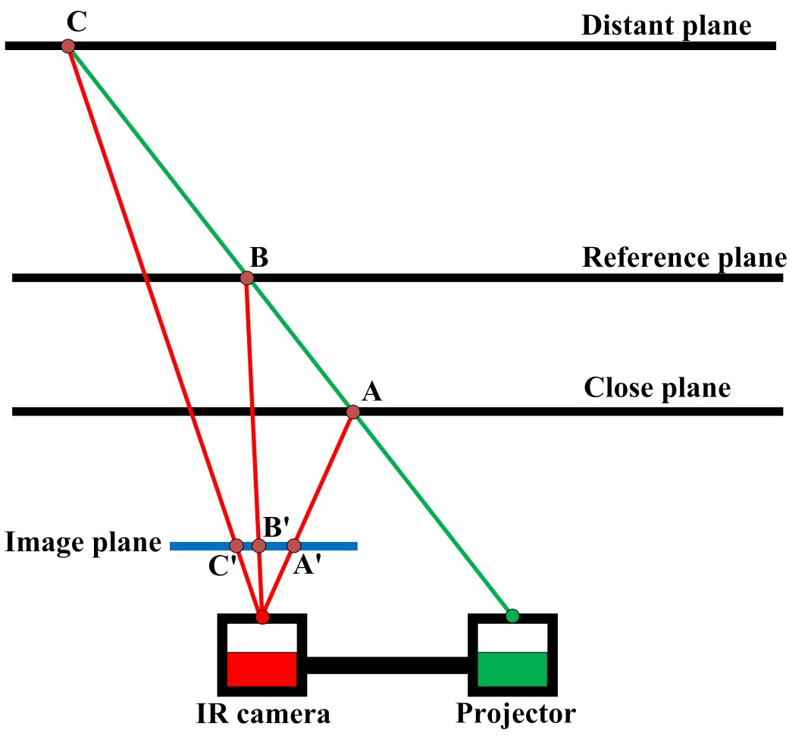

I suppose Projector transmits a beam of light along the green line, it will be captured as a blip by IR camera to the touch surface of objects in space. Let us consider three planes at three different distances: plane near Kinect (close plane), flat surface away from the Kinect (distant plane) and the reference plane (reference plane) in between two planes on. In particular, the reference plane previously known underground inside Kinect with full information about the distance. In addition, we also mention the image plane (image plane) of the IR camera, the projected plane of the points in space earned by the IR camera. Let us consider the three cases when the green light touch on three planes three-point turn is A, B, C; Three points are projected onto the image plane, respectively A ', B' and C '. Observe position A ', B' and C ', have commented: A's closer Kinect (or close as close Kinect plane) then A 'as far B' towards the right; conversely, point C as far Kinect (or as far distant plane

Kinect), then C 'as far B' on the left side. From there, when we know in advance the direction, the starting point of the light from the projector and position B 'is the projection of point B on the reference plane to the image plane, we absolutely can calculate the depth image or distance to an object.

Kinect does the same thing with the collection of the remaining bright spots broadcast from the projector, with the reference plane in advance. It finds the location is at the heart of blip that the IR camera capture and similarities of blip that on the reference plane (eg Figure 2.7 we have A and B, C and B are the pairs of similarities) to find the difference between these two points horizontally when projected on the plane of the image; and noted that the difference value is calculated in units of pixels. Gather all the difference value from the set blip, will create a map difference (disparity map), this value the greater the distance or the value of the depth image (depth) greater, from which we build depth map (depth map) with values ​​actually measured in meters. However,

According to calculations by Nicolas Burrus [6], one of those who paved the way for learning about Kinect through his experiments. He formulated the relationships between real values ​​z distance in meters and the value of the difference d:

*z*  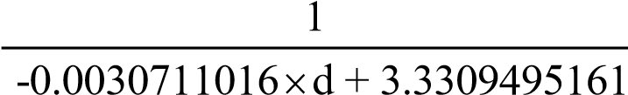

Where d is the integer represented as 11 bits, which is about to change from 02047. As a result of experimental measurements on OpenNI library, z values ​​varying between 0.56.0 meters and a depth map stable 0.55.0 meters. Therefore, the value d really varied between 4341030. Thus, in the space of

00.5 meters in front of the Kinect, Kinect can not put on the depth map, this is a drawback will be overcome and addressed in chapter 7.

**4.1.4. Some other characteristics**

Some other features of Kinect concern: the focal length and aperture angle camera (field of view), the supply and consumption capacity, the operating environment. Kinect is Microsoft's commercial products should the detailed specifications are not published. The parameters presented below are results of experimental measurements:

▪ Focal, open angle and RGB camera IR camera:

RGB and IR are two cameras spaced 2.5 cm should be slightly different in the two frames collected from the camera. To ensure RGB frames can accommodate IR frame, it is designed to open the RGB camera angle larger. This also led to the focal length of the camera RGB smaller. The parameters in Table 2.1 are measured empirically:

|  |  |  |  |
| --- | --- | --- | --- |
| **feature** | | **RGB**  **camera** | **IR camera** |
| **Field of View (degrees)** | *Horizontal* | ~ 62 degrees | ~ 58 degrees |
| *Vertical* | ~ 48 degrees | ~ 44 degrees |
| *Diagonal* | ~ 72 degrees | ~ 69 degrees |
| **Focal length (pixels)** | | 525 | 580 |

**Table 2.1: open angle and focal length of the camera RGB and IR**

▪ Power supply and power consumption:

Since Kinect require more power to operate so the USB port of the Xbox-360 can not meet that right through a gate split to split into two private connections are USB and power connectors, allowing devices to connect to Xbox-360 by USB while Kinect's power requirements are taken from 12VDC adapter. Xbox-360 versions will not need adapters since it has the special AUX port to provide connectivity. For USB connections are completely able to communicate with the computer Kinect. Replacing the battery power adapter 12V used on mobile robots are added in appendix 2.

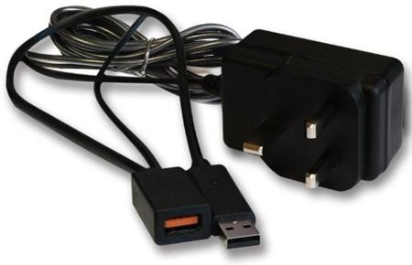

**Figure 2.8: Kinect adapter**

Power consumption measured experimentally:

|  |  |
| --- | --- |
| Power Consumption (idle) | ~ 3.3W |

#### Power consumption on Kinect

▪ Operating environment:

Kinect is a device designed for use in indoor environments (indoor). In the outdoor environment, the test results for the depth map is incorrect at the time of strong light, but for acceptable results when low light (at the time of the evening).

**4.2. Kinect SDK library, and Point Cloud OPENNI library:**

**4.2.1. Library support Kinect:**

As soon as new born, Kinect has been interested by a lot of software development, not only on the array develop games for Xbox, but also on the array of image processing applications in medicine, robotics, mapping ... So many libraries written for the Kinect launch. Until the present time, the library is worth noting that Libfreenect, Code Laboratories Kinect, Kinect SDK OpenNI and beta.

* ***Libfreenect:***

Libfreenect [7] is a library developed by OpenKinect, by a community of people interested in the Kinect hardware write out and share. OpenKinect community work entirely voluntary and not-for-profit, they developed an open source Libfreenect for different operating systems Windows,

Linux and OS X. Currently, Libfreenect be packaged for use in Python, C, C ++, C #, Java JNI, Java JNA, Javascript.

* ***Code Laboratories Kinect:***

Code Laboratories (CL) [8] is a company specializing in support for software developers, programmers exploit the features of the image processing device. Among them Kinect is not the exception, CL provides users with the most basic features of the Kinect camera, audio and motor.

* ***OpenNI:***

Library OpenNI [9] considered libraries the most powerful in the presence of Kinect SDK beta, this library supports multi-languages ​​on multiple different platforms, allowing developers can write applications on Kinect very easy to interact naturally natural interaction (NI). The main purpose of OpenNI is to build a standard API that allows library capable middleware combined with the power to increase the Kinect.

* ***Kinect beta SDK:***

Kinect SDK [10] beta is Microsoft launched June 16, 2011, is a powerful programming tool for developers. It allows programmers access the full functionality of the device Kinect. An inconvenience is only supporting libraries on Microsoft's programming tools like Visual Studio 2010 with C ++ language,

C # and Visual Basic. The outstanding features such as photo collection from sensors, skeleton tracking and voice control via voice recognition tool, Windows Speech Recognition API. The beta version is currently only allowed to use in the non-profit purposes, the commercial version promises to soon launch in 2012. The latest beta versions are updated on November 1, 2011 with many errors is correct and runs fine on Windows 8 Developer Preview.

To the present time, two libraries and Kinect SDK Beta is OpenNI wise choice for programming on Kinect by features strong support of the two libraries. Section 3.2 will analyze and compare the two libraries and library selection suitable for the dissertation.

**4.2.2. Kinect beta SDK compare and OpenNI**

Following are comments on the strengths and weaknesses of the two libraries on [11] (note the Kinect SDK is in beta so there will be few changes point to the last official version)

* ***Kinect beta SDK:***
  + *Advantage:*

+ Supports audio processing.

+ Support elevation angle control motor.

+ Skeleton tracking (grip characteristic body): no need to calibrate before clinging, clinging still good in the case of the human body turned around.

+ Supports access of Kinect sensors simultaneously.

+ The simple installation.

* + *Defect:*

+ Only for non-commercial purposes.

+ Clinging only support whole body characteristics (non-tracking mode hand or body part like grip on OpenNI).

+ Does not support gesture recognition.

+ Only supported on Win7 (x86 and x64) with high demands:

* + - Computer dual-core, 2.66 GHz speed or faster.
    - Windows 7 with support of DirectX 9.0 or higher.
    - Minimum 2 GB Ram.
    - Programming in Visual Studio 2010.

+ Does not support the collection of images directly from the IR camera.

+ Kinect region not seen in about 00.8 meters before Kinect.

* ***OpenNI:***
  + *Advantage:*

+ Allows building applications commercialized.

+ Support detect gestures.

+Skeleton tracking: support partial grip and hand tracking human body through a link with the middleware. Moreover, the power consumption of the CPU is less than when using the Kinect SDK.

+ Supports access of Kinect sensors simultaneously.

+ Support for Windows, Linux and Mac OSX.

+ To enable access to images from the IR receiver on the camera.

+ Kinect region not seen in about 0.5 meters is acceptable before Kinect.

* + *Defect:*

+ Does not support the audio processing for the microphone array.

+ Skeleton tracking: characteristic body clinging many errors and were not stable in the Kinect SDK.

+ No support for motor control elevation angle (handle this problem with little tips combined with Kinect Laboratories Code, see appendix

first).

+ The installation is somewhat more confusing Kinect SDK.

***Conclude:*** Students also had time to work on both libraries, should have the following conclusions:

Kinect beta SDK OpenNI stronger grip characteristics in the human body is more stable, so it will respond exactly to the human body gestures; however to detect gestures we have to write the algorithm while on OpenNI has support available. In addition, more Kinect SDK OpenNI in support for audio processing, allowing building control applications more easily by voice.

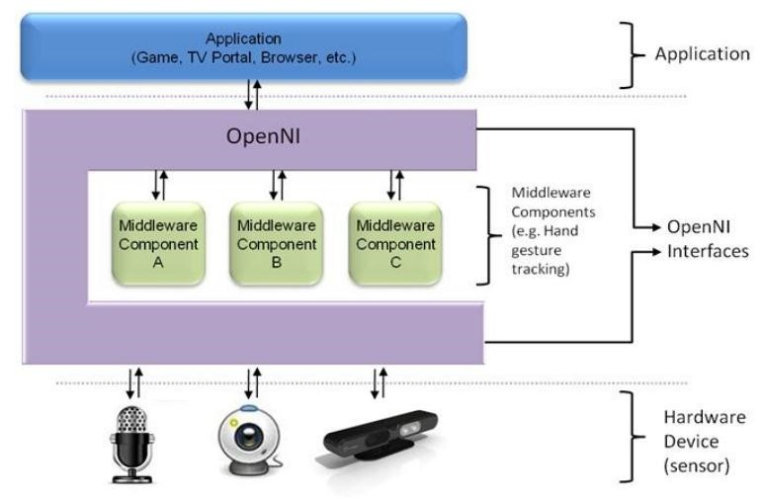

**OpenNI library coordination between hardware and application terminal**

OpenNI allows receiver depth map within the limits from 0.5 meters or forward Kinect while Kinect SDK, the limit is 0.8 meters forward, quality depth map grossed over two libraries are the same. Kinect SDK is nascent library is in beta stage and there is no support from the other image processing libraries as Point Cloud. Meanwhile OpenNI predecessors and almost integrated with image processing libraries Point Cloud. Therefore, with applications in the topic Kinect autonomous robot avoid obstacles, the OpenNI is more optimal choice. That is why students choose OpenNI library in conjunction with Point Cloud for this thesis.

Speaking of further vision, we see: the popularity, OpenNI may develop on the basis of different operating systems, and received contributions from the community to build a large open source; about business, we can develop the products commercialized in the market in many areas such as robotics, medical, education, entertainment ...

Library support Kinect helps us take pictures of depth and a number of other special features (such as skeleton tracking, hand tracking, gesture recognition on OpenNI); to make optimal use of its power to combine with image processing libraries in 3D space is Point Cloud that will be discussed in section 3.3.

**4.2.3. Point Cloud Library**



#### **Point cloud library logo**

PCL [12] is library support for nD Point Cloud for image processing in 3D space. Libraries are built with multiple algorithms such as filtered (filtering), restore the surface (surface reconstruction), partitioning (segmentation), estimate the characteristics (Feature Estimation), ... PCL can be used across multiple platforms such as Linux, MacOS, Windows and Android. To simplify the development, PCL is divided into several small library and can be compiled separately. The latest version is 1.3 PCL launched in October 31, 2011. PCL is completely free for research or development of product commercialization.

PCL can say is the combination of many small modules. These modules are also intrinsic library functions performed separately before being packed PCL. The basic library are:

* ***eigen:*** a library open support for linear operation, which is used in most of the mathematical calculation of the PCL.
* ***Flann:*** (Fast Approximate Nearest Neighbors Library for) support the quick search neighboring points in 3D space.
* ***Boost:*** makes sharing pointers on all modules and algorithms in

PCL to avoid duplication of copying data has been taken on in the system.

* ***VTK:*** (Visualization Toolkit) support for multiple platforms in the collection of data

3D, supporting the show, estimating volumetric objects.

* ***CMinPack:*** a library open help for solving linear operation and nonlinear.

**4.3. Recognition programs and output frame coordinates person**

Sensor_SkeletonFrameReady void (object sender, SkeletonFrameReadyEventArgs e)

{

using (var frame = e.OpenSkeletonFrame ())

{

if (frame! = null)

{

canvas.Children.Clear ();

Skeleton [] = new skeleton skeletons [frame.SkeletonArrayLength];

frame.CopySkeletonDataTo (skeletons);

var skeleton = skeletons.Where (s => == s.TrackingState SkeletonTrackingState.Tracked) .FirstOrDefault ();

if (skeleton! = null)

{

// Calculate height.

double height = Math.round (skeleton.Height (), 3);

// Draw skeleton joints.

foreach (joint JointType in Enum.GetValues ​​(typeof (JointType)))

{

DrawJoint (skeleton.Joints [joint] .ScaleTo (640, 480));

}

// Display height.

tblHeight.Text = height.ToString ();

Joint j = skeleton.Joints [JointType.HipCenter];

if (j.TrackingState == JointTrackingState.Tracked)

{

txtA.Text = (j.Position.X * 1000) .ToString ();

txtB.Text = (j.Position.Y * 1000) .ToString ();

txtC.Text = (j.Position.Z * 1000) .ToString ();

serial.Write (txtA.Text);

serial.Write ( "a");

serial.Write (tblHeight.Text);

serial.Write ( "b");

}

}

}

}

}

private void DrawJoint (Joint joint)

{

Ellipse ellipse = new Ellipse

{

Width = 10,

Height = 10,

Fill = new SolidColorBrush (Colors.LightCoral)

};

Canvas.SetLeft (ellipse, joint.Position.X);

Canvas.SetTop (ellipse, joint.Position.Y);

canvas.Children.Add (ellipse);

}

In the program includes functions: Identify the joints, came out coordinates, draw the joints skeletal person for monitoring and debugging, the transfer function coordinates to the microcontroller ... in functions that include many classes Kinect support such Skeletontracking, Skeleton ... Take advantage of this function to build up the program according to the tracking algorithm was the average in chapter 2 section 4.

Results when analyzing the skeleton:

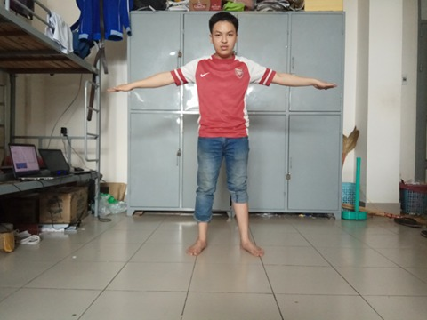

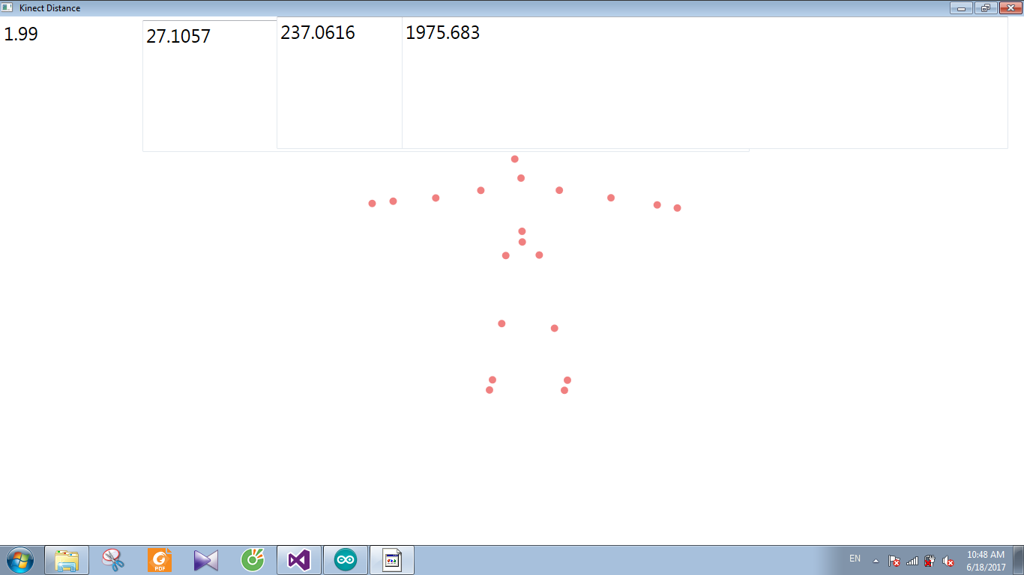

Coordinates according to 2 x and z are transmitted to the master microcontroller, and from microcontrollers to 3 master transmits the slave microcontroller to control the motor speed according to the PID algorithm for tracking robot can follow people.

**Chapter 5: Software android interaction between patients and robots.**

The interaction between people and robots is very important. Also with a service robot, adding utility to the user is very important. Therefore you have programmed an android software to meet the requirements that the certified skills:

* **Health Monitoring:**

+ Measurement of heart rate

+ Calorie consumption

+ Hint reasonable diet.

+ See weather

* **Utilities:**

+ Nearest hospital

+ Tree nearest ATM.

+ Nearest bus station.

+ Gourmet shop.

+ Favorite Places.

+ Tips for Life

* **Advanced:**

Call and sms automatically - emergency to relatives when the problem occurred.

## 5.1. The main interface of the program:

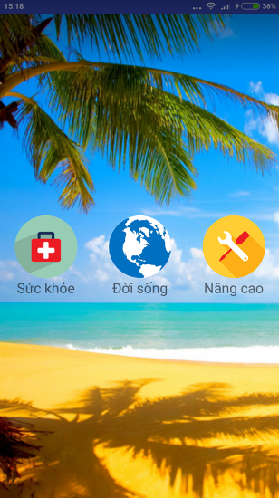

The main interface of the program includes three major features: health, life, enhanced.

## 5.2. Health:

* Measuring and tracking features heart rate:

Based on flash and camera phones, we can shed into the blood vessels inside the finger, based on the speed of movement of blood we can determine the current heart rate is.

This is a new algorithm developed by MIT. First, the flash will light up when placed forefinger at the camera, the camera will be shed into the blood vessels. Here, when the elasticity of blood vessels, the red will change the brightness according to the rhythm (cardiac pressure intermittent). And we rely on the change this cycle to calculate the cycle of veins in fingers pointing. Between consecutive cycles, we compute the average cycle. This is the average vein cycle at forefinger. Then, using the ratio of the pulse in the veins and the heart beats, we calculate the beats in the heart.

Here is the formula for changing brightness red zone:

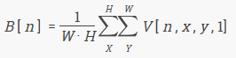

Inside:

W: Width of the image in pixels.

H: Height of the image in pixels.

v [n, x, y, 1]: The brightness of the red zone other regions remaining red by x and y coordinates.

This is the actual color of the blood vessels in the index finger while measuring:



Bright red areas will constantly change periodically. And since then I think the opposite is the heartbeat based on the statistical ratio of intravenous rhythm in the index finger and the heartbeat of MIT.

And we used to graph Achart Engine intravenous rhythm during measurement. And this is the result:

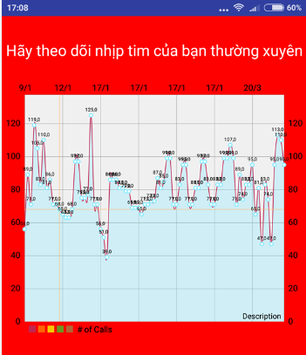

* **Calculate nutrient intake through food:**

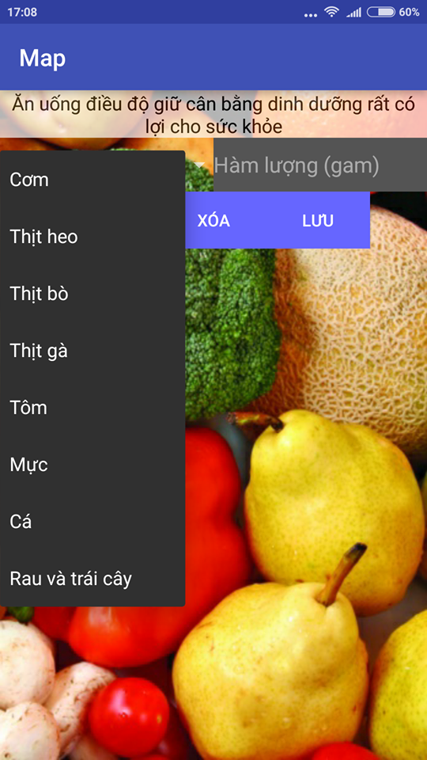

Users can enter the amount of food intake, based on the table of the nutrient content of the Institute National Nutrition, we will calculate the amount of the substance loaded into the body and give advice to people right.

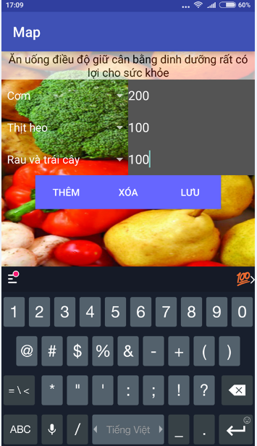

And this is the result:

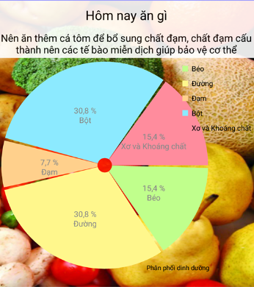

* **Weather**

The weather of the day will be updated through the API weather, weather data will be retrieved by the get the user's location and time to provide data on weather.

And here are the results:

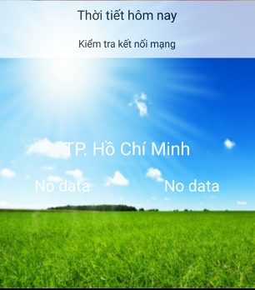

**5.3. Life:**

* Find the nearest hospital:

Based on the google map API returns the current location of the user, and we will use this API to find the nearest hospital.

Here are the results:

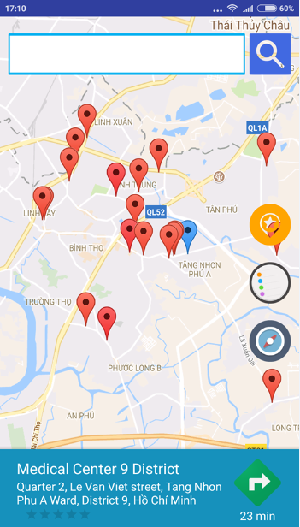

* Find the nearest ATM:

Similar to find the nearest hospital, we have the result:

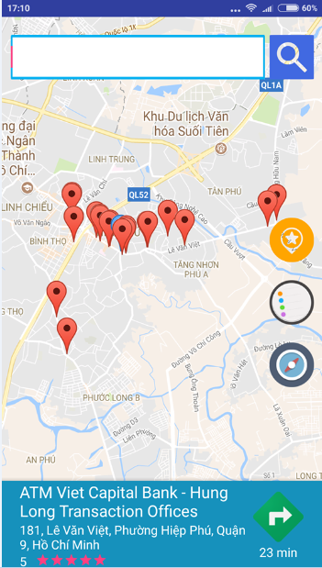

* Find the nearest diner:

Same as above, we get the following:

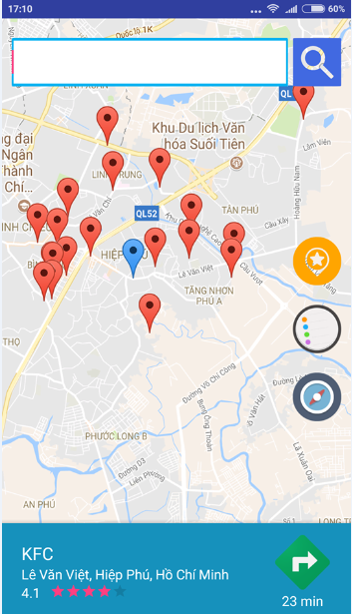

* Find the nearest bus station:

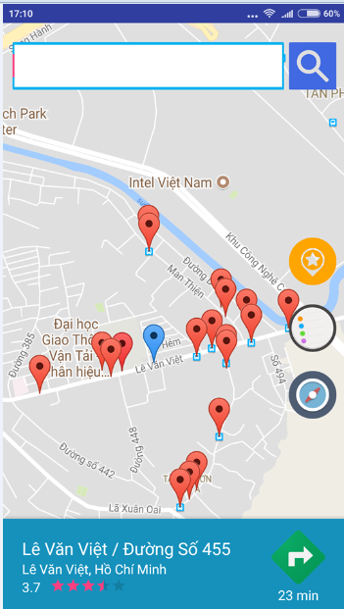

Finally interface overview of the life:

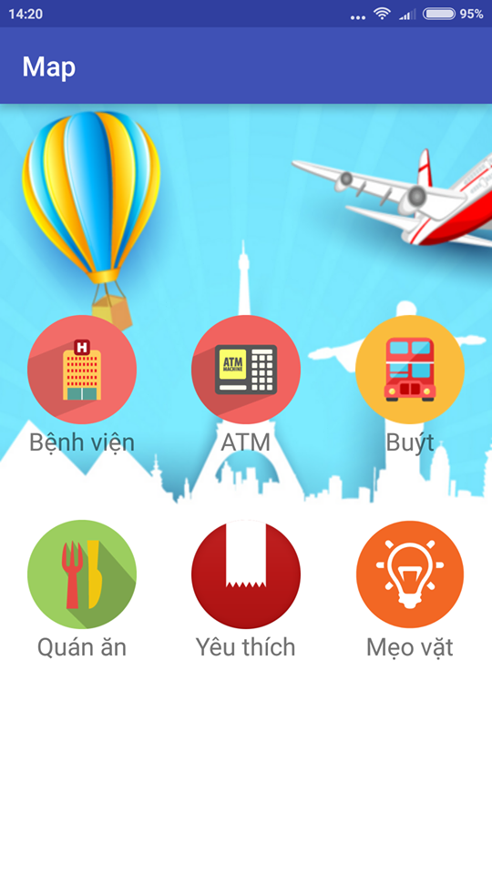

**5.4. Advanced:**

Users will set the phone number for private doctors and relatives to when the problem software will call and send emergency messages to relatives.

If you have any problems users simply press 2 times the HOME button on the screen of the robot, a message and an emergency call will be made to the number of doctors of private or family user previously established dirty.

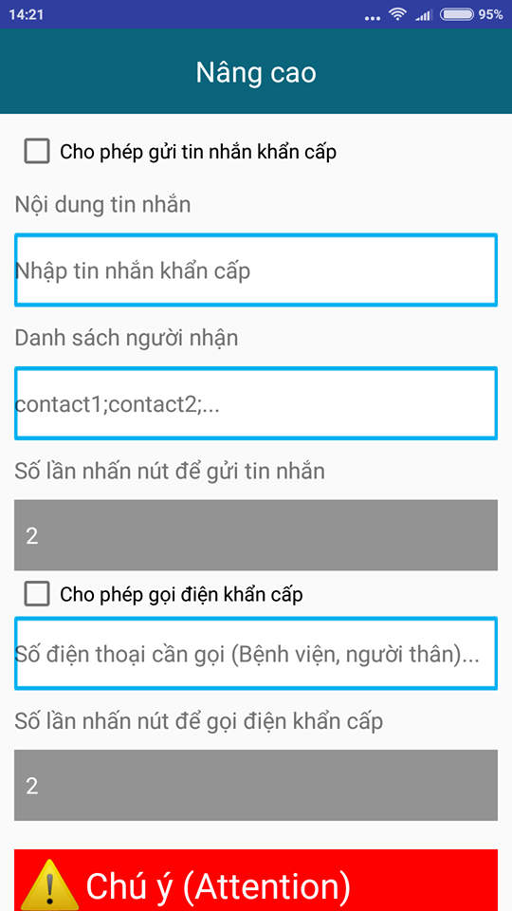

**Chapter 6: Handling voice with Sphinx library in JAVA language**

**6.1. About speech recognition technology**

Since the 50s of the 20th century, speech recognition technology has begun to be studied around the world. However, in Vietnam, this technology is still relatively new, only been studied in a lab.

Along with the development of AI, iodine, applying technology voice recognition becomes more a matter of course as the only system with voice control and voice over cars, laptops, components be smart ...

**6.2. Theoretical basis:**

Legal representation using the voice signal on a spectrogram (spectrogram). Spectrogram is useful for the analysis of phonemes and their transitions. A spectrogram of a signal time is a special two-dimensional representation, showing time and frequency horizontal axis vertical axis. A gray scale is often used to indicate the energy level at each point (t, f) with white only low energy levels and black is a higher energy level.

**6.2.1. Short time Fourier transform:**

Fourier transform can not be applied to the signal does not stop, because the frequency components unstable. However if we do not stop the signal divided into sections small enough, the signal over time in each segment can be considered a stop signal and thus can take the Fourier transform on this signal segments. Thus, the Fourier transform short time STFT (Short-Time Fourier Transform) has calculated positioning with frequency due to the nature of Fourier transform, has just had its positioning over time, as calculated in each period short. This is the principle of STFT aka chemical Fourier transform window. In STFT, signal f (t) is multiplied by a first window function w (t-τ) to obtain signals in a short time period around the time τ. Then normal Fourier transform is calculated on the segment signals.

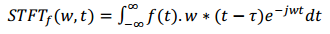

STFT at time τ is the Fourier transform of the signal f (t) multiplied with translated versions some time τ w (t-τ) of the basic window centered around τ. STFT taking position over time. Windows as narrow as possible positioning calculation.

**6.2.2. Short-time Fourier analysis:**

The idea behind the spectrogram is calculated Fourier transform each 5ms once, or perform energy at each time / frequency. Due to a few domain voice signal shorter than 100ms often appear periodically, we have used the techniques mentioned digital signal processing portion. However, the signal is no longer circulating when analyzing a longer period, thus, determining the accuracy of Fourier transform can not be used anymore. Moreover, the determination of which requires knowledge of infinite time signal. For two reasons, the new technique called the analysis a short time (short-time analysis) is proposed. These techniques analyze the voice signal into a series of short segments, called frames (frames) and analyzes each frame independently.

Performing Fourier short period for frame m are defined:

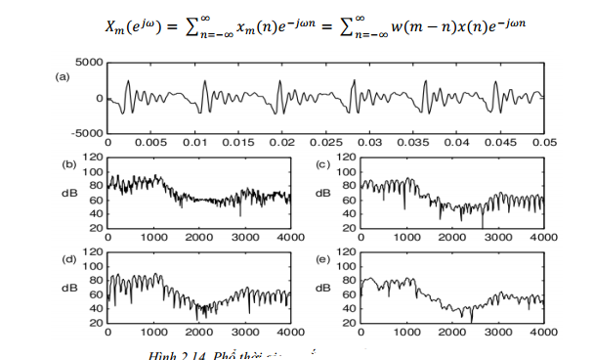

Due spectrogram display only energy and not limitation period should fourier transform energy level is calculated as follows:

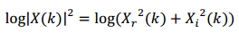

This value is transferred to grayscale Figure (2.16). The pixels that are not calculated value is added. Tilt adjustable sections of popular image contrast, while the saturation point which white and black adjustable kinematic sequence.

**6.3. Modeling**

**6.3.1. Hidden Markov model:**

An efficient method for modeling the structure of the voice is a hidden Markov model abbreviated HMM (Hidden Markov Models). This is the approach that match probability samples, with the assumption that there samples of voices sequentially over time as a result of the statistical process or random parameters, and these parameters can be estimated . Each word after cross stitch extract characteristic vector we obtain a P-dimensional array (P = coefficient MFCC), and are denoted as t1, t2, ..., ti, ..., tl. Quantum vector cross stitch, this characteristic vector sequence is converted into observations (as the symbols after layering quantum vector) and is denoted o1, o2, ..., ot, ...,  
*scruffy*. The underlying assumption of the HMM is a form of data that can describe the technique as the process of forming a random parameters, and the parameters of the guessing process can be estimated in the model are defined clearly and precisely . HMM basic theory was published in a series of documents of Baum and his colleagues.

This model includes the following features:

- From 1 status may arise more than 1 events (also known as 1 observations).

- Chains observed as a function of the probability of state.

- We can calculate the probability of the sequence of different status from one observation sequence.

Such HMM still generate observations. Number of other common status observe quantity. When in state Si, with probability p (o1) to generate events 1, the probability p (o2) to generate events 2 ...

**Example:** weather of a region with a probability as follows:

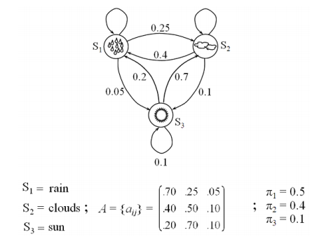

**6.3.2. Acoustic models:**

The accuracy of automatic speech recognition has always been one of the issues most important research. Model acoustic acts decided to improve accuracy and can be viewed as the central component in any system of identification.

With a string of observations acoustics given X = X1, X2, ... Xn, target of voice recognition is to find the sequence known respectively W = w1, w2, ... wn with posterior probabilities of maximum P (W | X) represented by the expression:

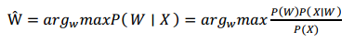

With fixed X, this expression when expression peak after peak:

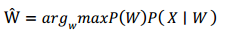

The problem posed is how to build the acoustic model, P (X | W) and language model P (W) really reflects the spoken language identification. For recognition with large vocabulary, need to analyze a language from the string into the (subword). Therefore, P (X | W) have a close relative with the syllable pattern. P (X | W) should take into account the change in speakers, pronunciation, surroundings and combinations dependent phonetic pronunciation context. Any model acoustic and language models which statistics can not meet the needs of practical application, so it is important to dynamically adapt the P (W) and P (X | W) to maximize P (W | X) in the use of spoken language systems.

* **Choose the appropriate units for the acoustic model:**

For speech recognition target vocabulary on the big building full 51 models from difficult because:

- Each new task contain new words without any available training data, such proper nouns and the new terminology is launched.

- There are too many words, and different from this can have different sound characteristics.

- The selection of the basic unit for performing characteristic acoustic and phonetic information for language is a very important issue in designing a workable system. Some issues to consider in choosing the modeling unit correctly:

- This unit must be accurate to represent the sound reality appear in different contexts.

- This unit must be trained. Must have sufficient data to estimate the parameters for this unit. Although the unit accurate and representative, they are less likely trained in the construction of a system feasible because nearly impossible to train repeated a hundred times for all of the words, unless we build an identity in a specific field.

- This unit must be generalized to any new words can also inherit from a predefined system for independent speech recognition tasks. If there is one fixed set of models from is almost no way to a new model from inheriting from it.

**6.4. Use the Sphinx and the actual operation of the speech recognition program written in JAVA language**

**6.4.1. Thie WORLD OF SPHINX:**

Currently there are 2 sets of tools to support speech recognition as inventories and Sphinx Vietnamese. However, there is no study to affirm what tools are best.

Sphinx is a speech recognition system written in Java language. It was created by the participation collaboration between groups Sphinx CMU (Carnegie Mellon University), Sun Microsystems Laboratories, Merl (Mitsubishi Electric Research Labs) and HP (Hewlett Packard), with contributions from UCSC (University of California at Santa Cruz) and MIT (Massachusetts Institute of Technology).

Main function:

- Voice recognition in direct mode and in batches, with voice recognition capabilities of discrete and continuous.

- Peripheral general architecture capable of fitting. Includes ability to add features pre-press (preemphasis), Hanning window, fast Fourier transform, elevator frequency filter Mel, modified discrete cosine, standardized Cepstral, and extract characteristic cepstra, delta cepstra, double cepstra delta. - Architecture general language model and potentially removable. Including support for language model ASCII and binary versions of unigram, Bigram, trigram, Java Speech API Grammar Format (JSGF), and ARPA-format FST grammars.

- Architecture model overall sound. Includes support of Sphinx3 acoustic model.

- The search for a general manager. Includes support and word search Breadth first pruning.

- Utilities for handling results after identification, including scoring trust, arising grids and ECMA script embedded in JSGF card. 67 independent tools include tools to display the waveform and spectrogram and extract features from audio files. Sphinx has become a framework identifying strong voice, has been used in many identification systems include the program by telephone as Cairo, freeswitch, JVoiceXML, ... the driver program like Gnome-VoiceControl, Voicekey, SpeechLion ... The benefits of using Sphinx: for the study of speech recognition based on a hidden Markov model:

- Sphinx default that Gaussian Mixture Model calculations and processing is separate search should be performed two types have different research without conflicting with each other. Examples can make a new observation probability without touching the source code performs a search. At the same time be able to build a new search algorithm without having to think about computation GMM, ...

- For the training, most of the time when we studied modeling, the desire to change the estimation algorithm. Baunm-Welch algorithm of SphinxTrain solve this problem in two phases: Insert the following statistical probability to a separate file and can easily be re-read by the library SphinxTrain. You can only work with the statistics and no need for her to pursue Baum-Welch training. This reduces research time.

- Powered by Sphinx is clearly written and easy to read. Many researchers.

**6.4.2. ARCHITECTURE SPHINX:**

Sphinx Framework was designed with flexibility and high modularity. Figure below shows a cover of the system architecture. Each component is labeled represents a module can easily be replaced, allowing researchers to test a different module without changing the rest of the system.

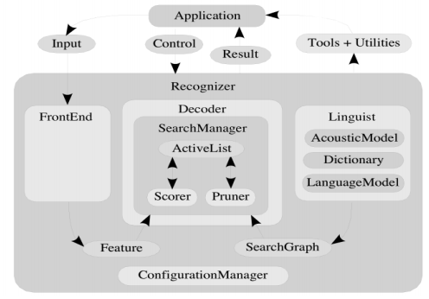

There are three main modules in Sphinx Framework: The peripheral (Frontend), decoder (Decoder) and the language (Linguist). Ministry peripheral receiving one or more digital signal and parameterize them into a range of features (Feature). Ministry languages ​​convert all models of standard language, along with information how to pronounce in the dictionary (Dictionary) and structural information from one or more sets of models acoustics (AcousticModel) on a map search marketing (SearchGraph). Ministry of search management (SearchManager) in decoder uses features from the periphery and graph search from the language to perform the decoding, arising results (Result). At any time before and during the identification process, application (Application) provides the controls to each module, become an effective partner in the identification process.

Sphinx4 system has a large number of configuration parameters to tune system performance. Configuration management component (ConfigurationManager) is used to configure the parameters. Configuration management suite also helps Sphinx4 can load and configure the module in runtime, make Sphinx4 become flexible and capable of fitting. Example Sphinx4 usually configured with a peripheral create the MFCC (Mel-Frequency Cepstral Coefficient). Using the configuration management capable Sphinx4 reconfigured to build a peripheral arising out of the PLP (Perceptual Linear Prediction coefficient) without having to modify the source code or 69 recompile the system.

Sphinx also provides a number of tools to help application developers and the ability to track the statistics of the decoder such as the rate of error, execution speed and memory use. As well as other parts of the system, the tool has powerful configuration capabilities, allowing users to perform system analysis. Furthermore we also offer an interactive runtime environment, allowing users to modify the parameters of the system while the system is running, enables rapid testing with many configuration parameters.

Sphinx4 utility also provides support to consider the application level (application-level) of the recognition results. For example, these extensions include support for viewing the results grid (lattice), the rated reliability (confidence scores) and language comprehension.

**6.5. Actual results of the robot run:**

She invited me and you watch the video of Heathcare Robot

https://www.dropbox.com/s/f58vtevx17pp7pd/IMG_8369.MOV?dl=0

**References**

1. Image processing textbooks - Tran Thuy Ha (Academy telematics)
2. Android programming textbooks (FPT - Aptech)
3. Composite technology curriculum (Polytechnic University of Hanoi)
4. Computer Vision (Aeron BobKich)
5. Sams Teach Yourself Android Application Development in 24 Hours (Lauren Darcey)